

Rehabilitation Research Design & Disability (R₂D₂) Center
PO Box 413
Milwaukee, WI 53201-0413

(414) 229-6803 phone
(414) 229-5628 TTY

Universal Access Projects

Community Design Solutions (CDS)

Annual Report
May 2008-May 2009

Community Design Solutions (CDS) aims to improve the quality of life in Wisconsin by designing or changing environments toward increased accessibility and refining decision making processes effecting the environment. CDS is involved in numerous projects including working with UWM’s R₂D₂ Center on the Milwaukee Idea Home, the ACCESS-ed Project, Design and Disability Instruction, and the Senior Home Assessment and Repair Project.

CDS Website: www.uwm.edu/MilwaukeeIdea/CDS/
R₂D₂ Center Website: http://www.r2d2.uwm.edu/

Table of Contents
Cover Page 1
I. Table of Contents 2
II. Executive Summary 3
III. The Universal Access Team 5
IV. 2008-2009 Project Achievements 6
▪ ACCESS-ed Project 6
▪ Design and Disability Instruction: 7
▪ Milwaukee Idea Home: 7
▪ UWM Campus Implementation of Physical Facility Design 9
▪ Websites: 9
V. 2009-2010 Planned Activities 10
1. ACCESS-ed/ UD ITEACH 10
2. Milwaukee Idea Home 10
3. Instruction 10
4. Senior Home Assessment and Repair Program (SHARP) 11
5. UWM Campus Implementation of Physical Facility Design 11
6. Website Design 11
Appendix A R2D2 Center Bibliography 13
2008 Projects 14
Presentations 2008 15
Thesis/Dissertation Research Projects 2008 16
Appendix B P3 Audit Example 17
Appendix C ACCESS-ed Posterette 19
Appendix D SHARP Home Assessment Evaluation Tool 20
Appendix E SHARP Process Flow Chart 36
Appendix F SHARP Spreadsheet 39
Appendix G SHARP Before and After Photos 39

Appendix H Equivalent Text Descriptions 39

Executive Summary


The Universal Design Team, based in UWM’s R₂D₂ Center and a component of CDS, successfully continued work on all projects. Following is a list of this years highlights:

- This past year the Senior Home Assessment and Repair Program (SHARP) completed assessments with seventeen homes with another ten homes in progress and ten on the waiting list.
- The ACCESS-ed Project successfully completed its 3rd year and moved into an extension year.
- ACCESS-ed produced a 2-day conference in September, 2008 on Universal Design in Higher Education and Beyond attended by over 70 participants.
- ACCESS-ed produced three presentations on accessibility measurement and universal design at the International Association of Higher Education and Disability (AHEAD) Conference, 2008 (one of which was a full day Capacity Building Institute (by invitation)). Two new proposals were accepted for the AHEAD 2009 conference. A report was written to Congress (invited) regarding project accomplishments and recommendations.
- SHARP team members presented the SHARP project at the International Conferences on Aging, Disability and Independence (ICADI) on February 22nd, 2008.
- The SHARP team updated protocols and procedures providing PantherFile as a key communication hub.
- R₂D₂ Staff provided ongoing training sessions and developed partnerships within the UW-System and with the State of Wisconsin Pathways to Independence group.
- Two of our graduate students completed research M.S. theses related to Universal Design.
- Three of our graduate students proposed new M.S. research theses related to Universal Design.
- A team of three of R₂D₂ staff and students taught a highly inter-disciplinary Design and Disability course in the Fall of 2008.
- The ACCESS-ed team developed 5 AUDIT’s (Accessibility and Universal Design Information Tools) to evaluate the accessibility of classroom instruction, services, media, and the physical environment.
- R₂D₂ updated our Accessible Design and ACCESS-ed websites and continued on the development of a ACCESS Mainstreet website.
- Our teams successfully wrote and received three grants for over one million: UD ITEACH (1,000,000) and Pathways I and II ($80,000).
- We also wrote a $46,000 proposal to the Retirement Research Foundation (still pending).
- R₂D₂ staff and students attend and present at the June 2008 Rehabilitation Engineering and Assistive Technology Society of North America (RESNA) conference in Washington, D.C.
- We presented our UD projects at the April 2009 American Occupational Therapy Association (AOTA) Conference in Houston, Texas.

This year’s activities continued to follow the theme of incorporating universal design (UD) into physical, instructional, and informational environments to promote cutting edge campuses and communities that shift from accommodating and adapting for individuals to infusing universal design and accessibility from the beginning. Overall, the past year’s activities have generated increased interest in the topics of universal design and accessibility in the community. We look forward to the upcoming year of activity.

The Universal Access Team

Roger O. Smith, Ph.D.
Professor, Occupational Therapy
Director, Rehabilitation Research Design & Disability (R₂D₂) Center

Staff Contributing to CDS Related Projects:
- Aura Hirschman, MS, CRC
- Melissa Lemke, MS, biomedical engineering
- Kathy Longnecker Rust, MS, OT
- Tereza Snyder, BFA, programming
- Randy Will, BS, engineering

Graduate and undergraduate students:
    - Thomas Dembski
    - Keith Edyburn
    - Amy Erfurth
    - Margaret Kastner
    - Jungeun Kim
    - Carrie Jennerjohn
    - Kati Liegl
    - Emily Lucht
    - Rochelle Mendonca
    - Crystal Schaaf
    - Kristi Vandenbush

2008-2009 Project Achievements

ACCESS-ed Project 

ACCESS-ed (Accessible Campus Climate Environment Support Systems for Education) is a project designed to develop and test processes that deliver low-cost universal design of instructional, information media, and physical environments to higher education campuses nation-wide. The project is supported in part by the U.S. Department of Education’s Office of Post-secondary Education and maintains a collaborative partnership with CDS. Over this past year, several ACCESS-ed workshops, presentations, and conferences have been conducted on topics such as measurement of accessibility on post-secondary campuses, how to infuse Universal Design knowledge and use, in post-secondary education (UDE), and replication of the Departmental Accessibility Resource Coordinators (DARC) system. In addition to providing information and workshops, ACCESS-ed has developed numerous resource tools, strategies, and products for universal design in post-secondary education. Posterettes have been created for educational purposes on many different topics including: Universal Design in Education, Accessible Logos, Bulletin Board Installation Guidelines, and Remodeling Guidelines (Refer to Appendix C for example). Audits continue to be created as a part of this project are available on the ACCESS-ed website (Refer to Appendix B for a sample audit). There has been continued research on the impact of universal design strategies in post-secondary education. The ACCESS-ed team started work on a second tier three-year grant proposal from the Department of Education called “Universal Design Infusion of Technology and Evaluation for Accessible Campuses of Higher Education (UD ITEACH)”. This project began in the spring of 2009.

- Design and Disability Instruction:

The Design and Disability (OCCTHPY 625) course brings together current and future professionals from different backgrounds and disciplines to teach the concepts and application of universal design. This course was taught as an elective in the fall of 2007 to students in the occupational therapy and architectural graduate programs among others. This course is a requirement for the Assistive Technology and Accessible Design Certificate and with its greater advertisement, more students have enrolled to take it as an elective. The course offers a new way of thinking creatively to apply the techniques of universal design in various settings and professions. The Assistive Technology and Accessible Design Certificate, mentioned above is a fifteen credit program focusing on the knowledge and application of assistive technology and universal design principles to prepare students for work in different areas of clinical practice. Support and collaboration for interdisciplinary students as well as involvement in student research has been provided throughout the past year of both SARUP and CHS graduate students. Thesis and dissertation instruction and advising continues to be provided for students within the R₂D₂ Center (Refer to Appendix A for Bibliography).

- Milwaukee Idea Home:

The MIH is a project of CDS that was designed and built for accessibility which is currently being used by IndependenceFirst as a transitional housing facility. The project is also being utilized for instructional purposes such as class demonstrations and field trips. It provides students an incredible opportunity to experience and learn about accessibiliy and universal design first hand.

MIH Website: www.uwm.edu/MilwaukeeIdea/CDS/


- Senior Home Assessment and Repair Program:

SHARP is a community-based project in which occupational therapy students from UWM collaborate with Layton Boulevard West Neighbors (LBWN) and Rebuilding Together Greater Milwaukee (RTGM). The team provides home assessments, recommends environmental modifications and adaptive equipment, and implements repairs to improve safety, function, and independence and promote aging in place for senior homeowners living in the Layton Boulevard community. SHARP is a multi-component program involving several sequencial steps. First, the LBWN coordinator recruits and interviews the homeowner and an occupational therapy assessment is scheduled. Next, after intoduction by the LBWN coordinator, a thorough occupational therapy assessment is conducted; the focus is safety and functionality of the older adult in their home. The subsequent step entails a home assessment by the RTGM team; the emphasis on repairing and remodeling the home to better fit the needs of the older adult. After all team members conduct and document their assessments UWM, LBWN, and RTGM meet to discuss recommendations and changes that need to be made to the home. The results of the meeting are shared with the homeowner for final review. The last step of the process is purchase/installation of adaptive equipment and implementation of the repairs/modifications of the home environment
Many changes have been made to SHARP including additions to the team and revisions in the process. In November of 2008, two new occupational therapy students were hired and trained to facilitate home assessements for SHARP. Another addition to the OT team is a community-based occupational therapist advisor who provides support to the UWM students and expert consultation for the home assessment process. A new coordinator for LBWN was also appointed. These new team members bring fresh ideas and perspectives to the SHARP process. Adjustments have been made to the program as a whole; in just a few months the assessment tool and protocol has been updated, the process has been evaluated in order to be more efficient, as well as recreating a comprehensive Excel document including UWM occupational therapy recommendations, RTGM scope of work, and LBWN follow up with homeowner that can be viewed/edited by all team members on the PantherFile account.
Due to limited funding and increased length of time between the occupational therapy assessment and completion of repairs/modifications, the team also re-assessed eight homes from last year. Following a proposal to the Faye McBeath Foundation, LBWN has just recently received funding for SHARP for another year in addition to exisiting funds from US Cellular and the Retirement Research Foundation. The participant list for 2009 includes two re-assessments as well as ten initial assessments. All houses on the participant waiting list are scheduled for completion by the end of the year. The team is looking forward to working with the new and improved program.


UWM Campus Implementation of Physical Facility Design

With the input of numerous colleagues, audit have been created to assess the design, usability, and accessibility of the campus. These audits have been used by professionals and students to evaluate different areas throughout the university and have been submitted to the campus implementation teams.

    - Websites:

R₂D₂ Center staff members continue to collaborate to provide technical assistance and support for the creation, edits, and launching of various, accessible R₂D₂ websites. The ACCESS-ed website continues to grow with newly created resources, e.g.

2009-2010 Planned Activities

Community Design Solutions allows us to continue working in a range of ways in the area of universal design and accessibility. As always, a set of new and continuing activities, including both community-based, and campus-based projects are anticipated for the current and coming year. Although we know the long list of activities that are desired can not all be accomplished in a short time, it is our hopes to continue with our current projects and expand our support for future projects. Planned activities include:

- ACCESS-ed/ UD ITEACH
      - ACCESS-ed will be wrapped up in 2009, following major research, resources, and the website which will continue availability.
      - Accessible products and resources as example for other websites, developers, etc.
      - Continued work on a three year grant and research titled “UD ITEACH, a Demonstration Project to Ensure that Students with Disabilities Receive a Quality Higher Education” beginning in October of 2008.

Milwaukee Idea Home
      - Continuation of home tours as part of instructional courses.

- Instruction
      - Fall Design and Disability course to graduate students across schools and colleges (CEAS, CHS, and SARUP).
      - Offering the new Assistive Technology and Accessible Design Certificate to both undergraduate and graduate students for continued education
      - Ongoing interdisciplinary support and collaboration to graduate students across colleges related to universal design.

- Senior Home Assessment and Repair Program (SHARP)
      - Completion of 10 home assessments by end of 2009.
      - Recruitment and training of new occupational therapy students as home assessors.
      - A thesis in the area of functional outcomes of home modifications to be conducted by occupational therapy graduate student, Crystal Ammann.
      - Incorporating the knowledge and skill of the architectural students from CDS.

- UWM Campus Implementation of Physical Facility Design
      - Coordination with Physical Plant about accessible design.
      - Support to the UWM library for remodeling.
      - Involvement in 20 year UWM Campus Master Plan
      - Audits of the campus environment for accessibility
      - Establishing campus committee for remodeling and new campus projects
      - Coordination on web kiosk implementation.

- Website Design
      - Updating and editing of the websites and improving the accessibility as an example to the public within the R₂D₂ Center website.

- Proposals and Projects
      - Proposal sent to the Retirement Research Foundation in May 2009 for a study “Matching Home Remodeling Services to Older Homeowner Needs: A Study of Effective Resource Utilization and a New Tool Promoting Aging in Place”.
      - Proposed project in 2009 “Pathways ACCESS Main Street”
      - Proposed project in 2009 Street AUDIT: Personal Information Resource on Accessibility”.

- Theses
      - Manuscript preparation of thesis work to be published by graduate students in the R₂D₂ Center
      - Five graduate students in the R₂D₂ Center beginning thesis work

- Collaboration and Community Outreach
- One of our R₂D₂ staff members, Aura Hirschman, has recently become actively involved in the UWM Chancellor’s ADA Advisory Center (ADAAC)

Appendix A

R₂D₂ Center Bibliograph

Presentations 2008
Anson, D. & Smith, R. O. (2008). Equivalent text descriptions - A proposed standard. Proceedings of the RESNA 31st International Conference on Technology and Disability: Research, Design, Practice and Policy.
Anson, D., Rust, K. L., & Smith, R. O. (2008). Equivalent Text Descriptions - Why and Where. Retrieved May 15, 2008, from http://access-ed.r2d2.uwm.edu/.
Anson, D., Smith, R. O., Hirschman, A., & Rust, K. L. (2008). Procurement tips for acquiring accessible goods and services that work for everyone including people with disabilities (Version1.2). Retrieved May 10, 2008, from http://access-ed.r2d2.uwm.edu/.
Anson, D., Hirschman, A., & Smith, R. O. (2008). Writing equivalent text descriptions (Version1.2). Retrieved May 6, 2008, from http://access-ed.r2d2.uwm.edu/.
Hirschman, A., & Smith, R. O. (2008). DARC Position Description Posterette. Retrieved May 15, 2008, from http://access-ed.r2d2.uwm.edu/.
Hirschman, A., & Smith, R. O. (2008). Top 10 tips for universal design in the classroom. Retrieved April 30, 2008, from http://access-ed.r2d2.uwm.edu/.
Mendelsohn, S., Edyburn, D. L., Rust, K. L., Schwanke, T. D., & Smith, R. O. (2008). Using assistive technology outcomes research to inform policy related to the employment of individuals with disabilities. Assistive Technology, 20, 139-148.
Mendonca, R., Smith, R. O., Lemke, M., & Winters, J. (2008). Expert validation of the MED-AUDIT (Medical Equipment Device-Accessibility & Universal Design Information Tool). Proceedings of the RESNA 31st International Conference on Technology and Disability: Research, Design, Practice and Policy.
O'Connor, T., Christiaansen, R., Anson, D., Rust, K., & Smith, R. (2008). Test and test items AUDIT (Version 1.6b). Retrieved April 30, 2008, from http://access-ed.r2d2.uwm.edu/.
Rust, K. L., Smith, R. O. & Will, R. (2008). Assistive technology consumer feedback - Prototype of a web based system. Proceedings of the RESNA 31st International Conference on Technology and Disability: Research, Design, Practice and Policy.
Rust, K. L., Anson, D., & Smith, R. O. (2008). Test and test item AUDIT (Version 1.6b) instructions. Retrieved April 23, 2008, from http://access-ed.r2d2.uwm.edu/.
Smith, R. O. (2008). OT FACT Application in Mental Health: An Update. In Barbara J. Hemphill-Pearson (Ed.), Assessments in Occupational Therapy Mental Health: An Integrative Approach, (Second Edition). Thorofare, NJ: Slack Inc.

Presentations 2008
Anson, D. & Smith, R. O. (2008, June 29). Equivalent text descriptions - A proposed standard. Poster Presentation at the RESNA 31st International Conference on Technology and Disability: Research, Design, Practice and Policy.
Knowland, D. P., Kelly, D., Lenker, J., Redepenning, S., Rakoski, D., & Smith, R. O. (2008, June 28). Developing assistive technology competencies to enhance clinical practice. Presented at the RESNA 31st International Conference on Technology and Disability: Research, Design, Practice and Policy.
Maggard, K. R. & Smith, R. O. (2008, February 22). Measuring the quality of text equivalents to multimedia information. Presented at the International Conference on Aging, Disability and Independence, St. Petersburg, FL.
Mendonca, R., Smith, R. O., Lemke, M., & Winters, J. (2008, June 29). Expert validation of the MED-AUDIT (Medical Equipment Device-Accessibility & Universal Design Information Tool). Presented at the RESNA 31st International Conference on Technology and Disability: Research, Design, Practice and Policy.
Mendonca, R. J., Jansen, C., Smith, R. O., John-Gomez, C., & Katz-Petted, L. (2008, February 22). Inter-Disciplinary Based Evaluation and Intervention for a Senior Home Repair Project. Presentation at the International Conference on Aging, Disability and Independence, St. Petersburg, FL.
Mendonca, R. J., & Smith, R.O. (2008, February 22). Quantifying the accessibility of medical devices: Development and validation of the MED-AUDIT. Presentation at the International Conference on Aging, Disability and Independence, St. Petersburg, FL.
Rust, K. L., Smith, R. O. & Will, R. (2008, June 28). Assistive technology consumer feedback - Prototype of a web based system. Presented at the RESNA 31st International Conference on Technology and Disability: Research, Design, Practice and Policy.
Smith, R. O., Hirschman, A., & Kastner, M. (2008, July 14). A student measure of campus accessibility: The ACES taxonomy. Presented at the 31st annual international AHEAD Conference, Reno, NV.
Smith, R. O., & Hirschman, A. (2008, July 16). Departmental accessibility resource coordinators (DARCS): A network approach to changing campus climate. Presented at the 31st annual international AHEAD Conference, Reno, NV.
Smith, R. O., Pickens, N. D., Rust, K. L., Siegler, S., & Mendonca, R. (2008, April 13). Evidence based measurement of accessibility for occupational therapy practice: Tools and techniques. Institute presented at the American Occupational Therapy Association, Long Beach, California.

Thesis/Dissertation Research Projects 2008
Kim, J. (2008). The effectiveness of using a protocol for preparing and delivering a universally designed presentation and its impact on students learning in higher education. Unpublished master's thesis, University of Wisconsin-Milwaukee.
Maggard, K. R. (2008). The efficacy of an equivalent text description protocol for increasing the accessibility of information. Unpublished master's thesis, University of Wisconsin-Milwaukee.
Paprocki, C. (2008). The effect of multifocal lenses on attentional capture. Unpublished master's thesis, University of Wisconsin-Milwaukee.

Appendix B

P3 Audit Example

Appendix C

SHARP Home Assessment Evaluation Tool

Home Safety and Accessibility Assessment:
The Senior Home Repair Project

Created by the R₂D₂ Center at UW-Milwaukee
(First Version by Rochelle Mendonca, Carleen Paprocki and Stephanie Siegler
Updated by Crystal Ammann and Kristi Vandenbush)

Based on the assessment created by Linda Balfanz at Rebuilding Together Greater Milwaukee

Introduction
1. Introduce yourself and other assessors present

2. Ask the homeowners if they understand why you are there and what you are going to do.

3. Explain the following:
- Here to make recommendations that will make their day to day lives easier
- Reduce obstacles in their home to make their home as safe as possible
- Goal is to keep them safe in their own home for as long as possible (may want to ask how long they have lived in their home for perspective)

5. Explain the following:
- To maximally help you, we need you to be open and honest with us.
- Don’t worry; everything will be kept confidential within the Layton Boulevard West Neighbors Project

7. “After a short interview, we will ask you to show us around your home and in each room we will make observations and ask you specific questions.”

- Is there anything you want to ask us before we begin?
General Information:
Homeowner(s) Name(s): _______________________________________________________
Homeowner(s) age(s): ___________________
Date of Home Assessment: _____________
Homeowner Address: __________________________________
Homeowner Phone: ____________

Occupational Therapist (Primary Assessor): ________________________________________
Other Attendees: ______________________________________________________________
Assessor Phone: _____________

Health Inventory:

- Homeowner known disabilities, impairments or health conditions:
⁯ Diabetes ⁯Arthritis ⁯ Surgeries (specify) _________________ ⁯ Fractures
⁯ Vision Impairments (specify) _____________ ⁯Cardiovascular Disease
⁯ Hearing Impairment (one or both ears/how severe) ___________________________
⁯ Injuries (specify when it happened and where) _______________________________
⁯ Other: (please specify) __________________________________________________
- Joint pain (note location)?
⁯ Shoulder L/R ⁯ Elbow L/R ⁯ Wrist L/R ⁯ Hands L/R
⁯ Back ⁯ Neck Upper/Lower ⁯ Hip L/R ⁯ Knee L/R
⁯ Ankle L/R ⁯ Foot L/R

Prompt for assessor: For example, do you ever have difficulty turning on and off faucets or opening door handles?

- Do you ever experience muscle pain and where (note location)?
⁯ Arm Upper L/R ⁯ Arm Lower L/R ⁯ Leg Upper L/R ⁯ Leg Lower L/R
⁯ Hand L/R ⁯ Back ⁯ Other: _____________________________

Prompt for assessor: For example, do you ever feel tired or in pain after carrying a load of laundry up/down the stairs or after making a meal for yourself?

- Do you use any type of ambulatory device/equipment? ⁯Yes ⁯ No
If so, what type of device(s): ⁯ Wheelchair ⁯ Walker ⁯Cane
⁯ Other: (please specify) __________________________________________________

Where do you use this ambulatory device? ⁯ Outside ⁯ Inside
⁯ Everywhere ⁯ Other: (specify what type) ________________ When or how often do you use this ambulatory device? ⁯ Always ⁯ Never ⁯ Sometimes
⁯ Other: (specify what type) ____________________________________

- Do use any type of auditory device or hearing aide? ⁯Yes ⁯ No
If so, what type of device: ⁯ Hearing Aide (one ear L/R) ⁯ Hearing Aide (both ears)
⁯ Other: (specify what type) ________________
When do you wear/use them and/or how often do you use them?
⁯ Always ⁯ During Day ⁯ Only at Home ⁯ Only Outside (of home)
⁯Other (specify): ______________
- Do you use any type of visual aide/corrective device? ⁯Yes ⁯ No
If so, what type? ⁯ Bifocals ⁯ Single lens ⁯ Trifocals
⁯ Contacts ⁯ Other: (specify type) ____________________
How long have you worn/used them? ____________________
When do you wear/use the visual aids and/or how often do you use them?
⁯ Always (when awake) ⁯ During Day ⁯ When reading ⁯ When Driving
⁯ Other: (please specify) ______________
Prompt for assessor: For example, do you have problems walking up and down stairs?
- Do you have/use any other types of assistive equipment such as:
⁯ Tub Chair ⁯ Hand Held Shower ⁯ Raised Toilet Seat
⁯ Tub Bench ⁯ Grab Bars___________ ⁯ Bedside Commode
⁯ Reacher ⁯ Long Handle Sponge ⁯ Long Handle Shoehorn
⁯ Sock aide ⁯ Other_______________

Are there any other areas that you think an assistive device would help you? ________________________________________________________________________
- How do you spend your time? _________________________________________

Prompt for assessor: For example, are you currently working full or part-time? What type of activities do you take part in during your free time such as volunteering or caring for others?
- Do you (the homeowners) have any other questions???
Outside The House
Observations:
- Type of residence: ⁯ one-story ⁯ two-story ⁯ other: (please specify) __________

- Steps at front entrance: ⁯Yes ⁯ No
Steps at back entrance: ⁯Yes ⁯ No
Steps at side/other entrance: ⁯Yes ⁯ No

- Number of handrails: front____ back____ side___
Type/Location of handrails: ⁯ Single (one side) ⁯ Double (both sides)
Secure: ⁯Yes ⁯ No
Good Condition: ⁯Yes ⁯ No
Measure height of handrails: __________________

- Number of steps: front____ back____ side____ step height: ______
Are the steps and walkway in good condition: ⁯Yes ⁯ No
Number of steps: front____ back____ side____ step height: ______
Are the steps and walkway in good condition: ⁯Yes ⁯ No

- Is there an Outside Light at front entrance? ⁯Yes ⁯ No
Working: ⁯Yes ⁯ No Adequate: ⁯Yes ⁯ No Describe: _________________

Is there an Outside Light at back entrance? ⁯Yes ⁯ No
Working: ⁯Yes ⁯ No Adequate: ⁯Yes ⁯ No Describe: _________________

Is there an Outside Light at other/side entrance? ⁯Yes ⁯ No ⁯ NA
Working: ⁯Yes ⁯ No Adequate: ⁯Yes ⁯ No Describe: ____________________

- Measure hallway width (from kickboard to kickboard): _______

- Measure Doorway width: front____ back____ side_____
Is the door way wheelchair accessible? ⁯Yes ⁯ No
If no, describe why? ______________________________________

- Is there a clear walkway (path) to enter house from the front: ⁯Yes ⁯ No
Is there a clear walkway (path) to enter house from the back: ⁯Yes ⁯ No
Is there a clear walkway (path) to enter house from the side: ⁯Yes ⁯ No ⁯ NA

- Is there a threshold at front entrance: ⁯Yes ⁯ No Height: _____________________
Is there a threshold at back entrance: ⁯Yes ⁯ No Height: _____________________
Is there a threshold at side entrance: ⁯Yes ⁯ No Height: _____________________

- Type of door handles: ⁯ Lever ⁯ Round ⁯ Thumb-push
⁯ Other (specify) _____________

- Number of locks at front entrance:____
Location of locks at front entrance: ___________
Type of locks (front entrance): ⁯ Single Cylinder ⁯ Double Cylinder
⁯ Other (specify) _________________________

- Number of locks at back entrance: ____
Location of locks at back entrance: ___________
Type of locks (back entrance): ⁯ Single Cylinder ⁯ Double Cylinder
⁯ Other (specify) _________________________

- Number of locks at other entrance: ____
Location of locks at other entrance: ___________
Type of locks (other entrance): ⁯ Single Cylinder ⁯ Double Cylinder
⁯ Other (specify) _________________________

- Location of mailbox: ___________________________________________________
Ask the homeowner(s) if they are able to get their mail safely? ⁯Yes ⁯ No

Specific Questions:
Prompt for assessor: “Let’s talk about your front (back or side) door.”

- Is it easy for you to walk/enter into the house through the front entrance? ⁯Yes ⁯ No
Describe: _______________________________________________________

- Is it easy for you to walk/enter into the house through the front entrance? ⁯Yes ⁯ No
Describe: _______________________________________________________

- Is it easy for you to walk/enter into the house through the front entrance? ⁯Yes ⁯ No
Describe: _______________________________________________________

- Do you have a porch light? ⁯Yes ⁯ No Is the light working? ⁯Yes ⁯ No

- Do you ever have difficulty identifying visitors? ⁯Yes ⁯ No
Describe (when, where, why): __________________________________________

Is there a door peephole viewer: ⁯Yes ⁯ No Height of peephole: ________

- Can you always hear the doorbell or knocks on the door? ⁯Yes ⁯ No

If not, are there specific areas in your home where you cannot hear the doorbell or knocks? Describe: _________________________________________

Is the doorbell in working order? If not, please circle appropriate response.

(Doorbell not working/ doorbell not loud enough/ insufficient speakers/
Other: (be specific) _______________)

- Do you ever have difficulty opening and closing your windows? ⁯Yes ⁯ No
Do your windows lock? ⁯Yes ⁯ No Describe how/type of locks: _________________

- Do you ever have difficulty managing the door locks and knobs/handles? ⁯Yes ⁯ No
Describe: _______________________________________________________________

- Are you able to easily get trash to the carts and to the curb for pick up? ⁯Yes ⁯ No ⁯ NA
Describe: _______________________________________________

- Are you able to easily get trash carts to the curb? ⁯Yes ⁯ No
Describe: _______________________________________________

- Do you have garage (or storage shed)? ⁯Yes ⁯ No
Is it easy or hard to access? Describe ____________________________

Inside The House-General
Observations:
- Are pathways free of obstacles/clutter? ⁯Yes ⁯ No

- Is there loose/frayed carpet? ⁯Yes ⁯ No Where is it located? __________________

- Number of lights in the house:
Adequate: ⁯Yes ⁯ No Describe: ______________________________________

- Measure the width of hallways: ________
Are the hallways wheelchair-accessible? ⁯Yes ⁯ No

- How many stairs are inside the home? Number upstairs: ___ Number downstairs: ___
Measure height of stairs: Stair Height Up: ______ Stair Height Down: ____________

- Type/Location of handrails: ⁯ Single (one side) ⁯ Double (both sides)
Secure: ⁯Yes ⁯ No
Good Condition: ⁯Yes ⁯ No
Measure height of handrails: __________________

- Is there non-slip material on the stairs? ⁯Yes ⁯ No Type: ____________________
Condition of non-slip material: ⁯ Good ⁯ Moderate ⁯ Bad ⁯ Other (specify) _____

- Is there a light switch at the top of the staircase? ⁯Yes ⁯ No
Is the light adequate? ⁯Yes ⁯ No

Is there a light switch at the bottom of the staircase? ⁯Yes ⁯ No
Is the light adequate? ⁯Yes ⁯ No

- Measure door knob height: __________

- Type of door knob: ⁯ Lever ⁯ Round ⁯ Thumb-push ⁯ Other (specify) _________

- Measure height of light switches: ________ Type of light switches: _______________

Specific Questions:
- Do you use throw rugs? ⁯Yes ⁯ No
Placement/Condition: __________________________
_________________________
- Can you easily read your emergency phone numbers? ⁯Yes ⁯ No
If not, describe why: ______________________________________________________

Location of emergency numbers: ____________________________________________

- Can you read and dial your telephone easily? ⁯Yes ⁯ No
If not, describe why: ______________________________________________________

Number of Portable Phones: _______
Location of phones _______________________________________________________

4. Do you have difficulty turning light switches on or off? ⁯Yes ⁯ No
If so, describe why: ______________________________________________________

5. Do you have difficulty opening or closing doors in the house? ⁯Yes ⁯ No
If so, describe why: ______________________________________________________
Which way do the doors open: _______________________

6. Do you keep any lights on at night? ⁯Yes ⁯ No
Location: ___________________________

7. Do you have nightlights? ⁯Yes ⁯ No
Location of nightlights: ______________________________________
Is the light adequate? ⁯Yes ⁯ No

8. Do you ever hold onto furniture or the walls while you walk around your home? Yes/No
If so, describe: _________________________________________________________

- Do you ever trip inside your home? ⁯Yes ⁯ No
If so, what causes you to trip/fall? ___________________________________________
How often do you trip or fall inside or outside or home? _________________________
Location of tripping/falls: __________________________________________________
In what rooms are you most concerned about falling? ____________________________

Living Room/Dining Room
Observations:
- Height of window sills: _________________

- Observe any walking path obstructions:
_______________________________________

- Observe general lighting/adequacy:
__________________________________________

- Height of light switches:
_________________________________________________

Specific Questions:
- Do you have any difficulty getting into and out of a sofa, or chair? ⁯Yes ⁯ No

- Do you have a favorite chair? ⁯Yes ⁯ No

How often do you have trouble sitting down in it or standing up out of it?
________________________________________________________________

- Do you have a remote control for your T.V.? ⁯Yes ⁯ No Type of remote: _________

Can you read the buttons on the remote control? __________________________

- Can you easily reach window blinds/shades/draw cord? ⁯Yes ⁯ No

- Can you change/open shades: ⁯Yes ⁯ No Describe: _______________________

Kitchen
Observations:
- Type of cabinets:
_______________________________________________________

- Height of cabinets:
______________________________________________________

- Type of drawer/cabinet pulls:
______________________________________________
Prompt for assessors: observe homeowner(s) opening/closing cabinets and using faucets

- Type of faucet handles:
___________________________________________________

- Height of controls on the stove and microwave:
________________________________

- Location of controls on the stove and microwave:
______________________________

- Height of freezer:
________________________________________________________

- Is there a seating area in the kitchen: ⁯Yes ⁯ No Table in kitchen: ⁯Yes ⁯ No

- Observe general lighting locations/adequacy:
___________________________________

Specific Questions:
- Can you easily reach/use cupboards or storage space? ⁯Yes ⁯ No Describe:__________

- Do you use a step stool: ⁯Yes ⁯ No

- Do you feel safe using the stepstool: ⁯Yes ⁯ No If no, describe why: _______________
Prompt for assessors: observe homeowner(s) using the stepstool

- Do you have difficulty lifting/transporting items during meal preparation? ⁯Yes ⁯ No
If yes, describe why: __________________________________________________

- Can you easily open/close drawers/cabinets? ⁯Yes ⁯ No
If no, describe why: __________________________________________________
- Do you have any difficulty working at the sink/counter or using the faucets? ⁯Yes ⁯ No
If yes, describe why: _________________________________________________________

- Do you have any difficulty using the stove/microwave? ⁯Yes ⁯ No
If yes, describe why: _________________________________________________________

- Are you able to easily read the microwave buttons? ⁯Yes ⁯ No

- Can you easily open/close, and get items in the refrigerator? ⁯Yes ⁯ No

- Can you easily reach into the freezer to get out items? ⁯Yes ⁯ No

- Do you get tired easily while making meals? ⁯Yes ⁯ No
If yes, describe why: _________________________________________________________

- Do you have a fire extinguisher/baking soda in case of a stove fire? ⁯Yes ⁯ No

Bedroom #1
Observations:
- Door entrance width: __________

- Light switch location:
_____________________________________________________
Can they reach the light switch from bed? ⁯Yes ⁯ No

- Telephone location: _______________________________________________________
Can they reach the light switch from bed? ⁯Yes ⁯ No

- Type of drawer pulls? _____________________________________________________

Specific Questions:
- Can you easily get into and out of the bed? ⁯Yes ⁯ No
If no, describe why:
_______________________________________________________

- Can you easily move around the bedroom? ⁯Yes ⁯ No
If no, describe why:
_______________________________________________________

- Can you easily open closet doors, reach clothing, coats, shoes/other closet items? ⁯Yes ⁯ No
If not, describe why: ______________________________________________________

- Can you easily reach, open and close all dresser drawers? ⁯Yes ⁯ No
If no, describe why:
_______________________________________________________

Bedroom #2 (if used)
Observations:
- Door entrance width: __________

- Light switch location:
_____________________________________________________
Can they reach the light switch from bed? ⁯Yes ⁯ No

- Telephone location:
_______________________________________________________
Can they reach the light switch from bed? ⁯Yes ⁯ No

- Type of drawer pulls?
_____________________________________________________

Specific Questions:
- Can you easily get into and out of the bed? ⁯Yes ⁯ No
If no, describe why:
_______________________________________________________

- Can you easily move around the bedroom? ⁯Yes ⁯ No
If no, describe why:
_______________________________________________________

- Can you easily open closet doors, reach clothing, coats, shoes/other closet items? ⁯Yes ⁯ No
If not, describe why: ______________________________________________________

- Can you easily reach, open and close all dresser drawers? ⁯Yes ⁯ No
If no, describe why:
_______________________________________________________

Bathroom
Observations:
- Type of faucet handles: __________________________________________________

- Type of shower handles: _________________________________________________

- Measure Height of sink: ____________

- Measure Height of faucet: ___________

- Measure Height of medicine cabinet: _________

- Measure Height of toilet seat: ___________

- Is toilet seat raised? ⁯Yes ⁯ No

- Are there Grab bars? ⁯Yes ⁯ No Location of grab bars: _______________________

- Measure tub edge height: _________

- Is there a non-slip tub floor or mat? ⁯Yes ⁯ No

- General Lighting/Locations/Adequacy: ________________________________________

- Measure Door width: __________

Specific Questions:
- Do you have any difficulty using the sink or the faucets? ⁯Yes ⁯ No
If yes, describe why:
_______________________________________________________

- Do you have any difficulty using or storing personal care items near the sink/tub/shower? ⁯Yes ⁯ No
If yes, describe why: ____________________________________________________

- Do you have any difficulty storing or removing items from the closet shelves: ⁯Yes ⁯ No
If yes, describe why: _______________________________________________________

- Do you have difficulty stepping into/out of the bath/shower? ⁯Yes ⁯ No
If yes, describe why: _______________________________________________________

- Do you have any difficulty using the tub faucets, shower control, or drain plug? ⁯Yes ⁯ No
If yes, describe why: _______________________________________________________
Do they work? ______________________________________

- Do you have any difficulty taking a bath or a shower? ⁯Yes ⁯ No
If yes, describe why: _______________________________________________________

- Do you have any difficulty getting on/off the toilet? ⁯Yes ⁯ No
If yes, describe: ___________________________________________________________

- Do you have any difficulty reaching the toilet paper? ⁯Yes ⁯ No
If yes, describe: ___________________________________________________________

- Do you ever get tired standing at the sink? ⁯Yes ⁯ No
If yes, describe: ___________________________________________________________
If yes, do you ever use a stool or seat? ⁯Yes ⁯ No

Basement/Laundry Room
Observations:
- Location of washer and dryer: _____________________________________________

- Height of washer/dryer controls: ____________________________________________

- Location of washer/dryer controls: __________________________________________

- Adequate contrast, size, and readability of washer/dryer controls: ⁯Yes ⁯ No

- Type of washer/dryer: ⁯ Front Load ⁯ Top Load ⁯ Other (specify) ______________

- Number of hand rails: _____

- Location of hand rails: ____________________________________________________

- Measure Stair Height: _________

- Number of stairs: _______

- Non-slip material on stairs: ⁯Yes ⁯ No Contrast on stair treads: ⁯Yes ⁯ No

- Is the area free of clutter? ⁯Yes ⁯ No

If not, describe what: _________________________________________________________

- Measure Height of storage cabinets: ___________

- Type of Lighting: ___________________
Is there a light at top of stairs? ⁯Yes ⁯ No
Is there a light at the base of the stairs? ⁯Yes ⁯ No

Specific Questions:
- How do you transport your laundry to and from the washer? __________________________

- How do you transport your laundry to and from the dryer? ___________________________

- Do you have any difficulty using or seeing the dials on the washer/dryer? ⁯Yes ⁯ No
If yes, describe: __________________________________________________________

- Do you use basement for storage? ⁯Yes ⁯ No
If so, what do you store there? ______________________________________________

Garage/Storage Shed
Observations:
- Is there an entrance on the side of the building? ⁯Yes ⁯ No
If yes, what type of lock: ⁯ Single Cylinder ⁯ Double Cylinder ⁯ Other (specify) _____

- Type of garage door: ⁯ Automatic ⁯ Manual ⁯ Other (specify) ________

- Location of lights: ____________________ Is the lighting adequate? ⁯Yes ⁯ No

- Type of lights: ⁯ Motion detected ⁯ Manual/Switch ⁯ Other (specify) __________

- Is there a clear pathway to the building? ⁯Yes ⁯ No

If no, describe: ___________________________________________________________

Specific Questions:
- Do you have an automatic door opener? ⁯Yes ⁯ No

- What do you use this unit for? ______________________________________________

- Do you have any difficulty using accessing the garage or storage unit? ⁯Yes ⁯ No
If yes, describe: __________________________________________________________

Appendix D

SHARP Process Flow Chart

Approval By LBWN
OT assessment in client's home:
1. Functional assessment
2. Environmental assessment
3. Social situation
OT Recommendations reviewed by Rebuilding Together
Rebuilding Together's Assesment in client's home:
1. Repair assessment
2. City code assessment
Outcomes Summary
Combination of OT recommendations prioritized, Rebuilding Together repair recommendations priortized, and cost estimates from contractor
Collaborative Revisions and final repair recommendations made by all three
Complete Homeowner approval contract
Completion of repairs and adaptations by contractor
Homeowner Evaluation of home modifications made
Image 1:
SHARP Process Flow Chart

Appendix E

SHARP Before and After Photos
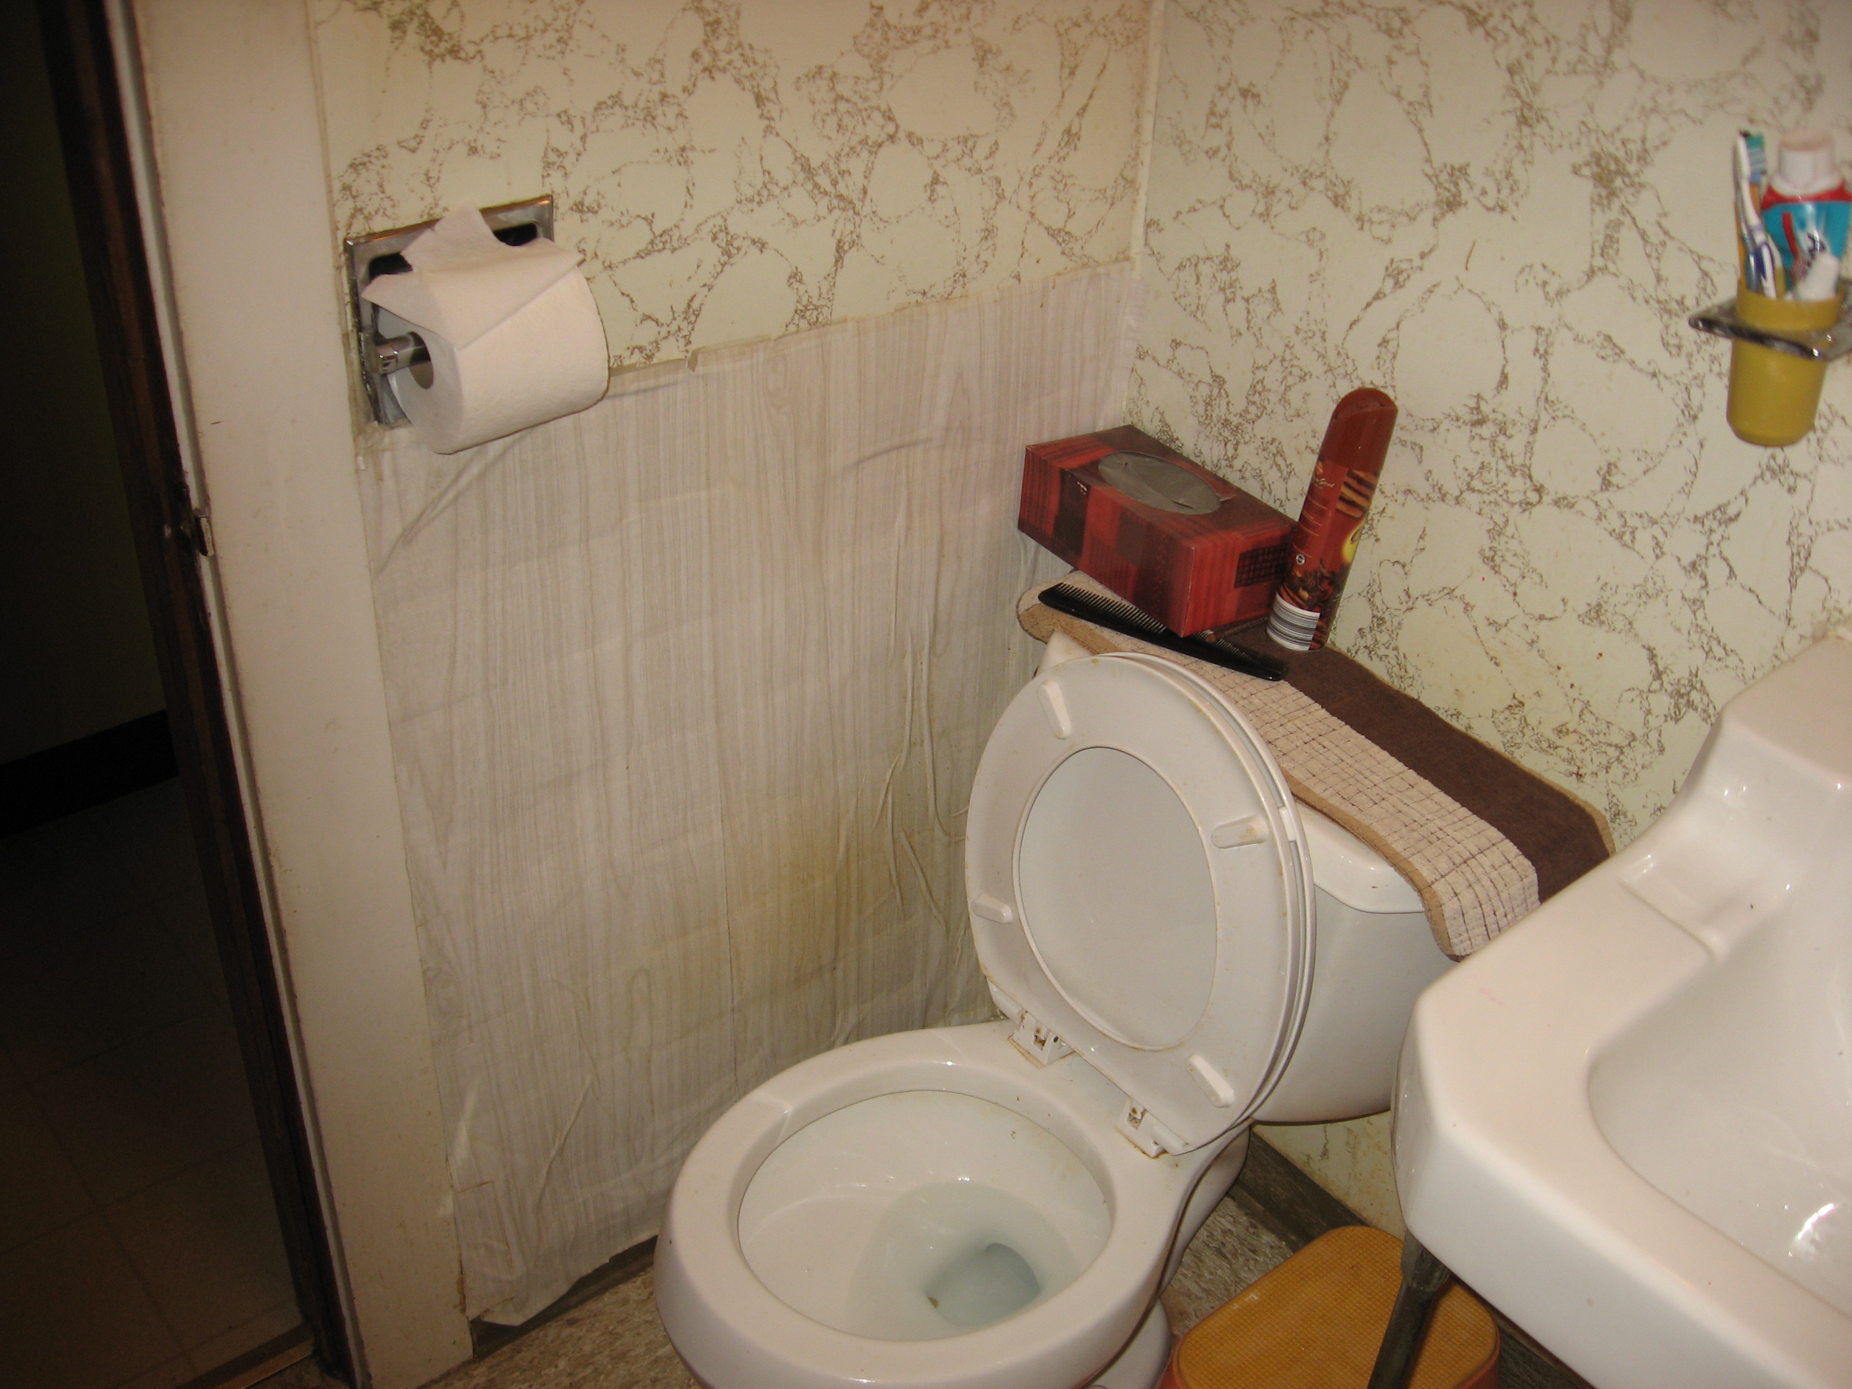

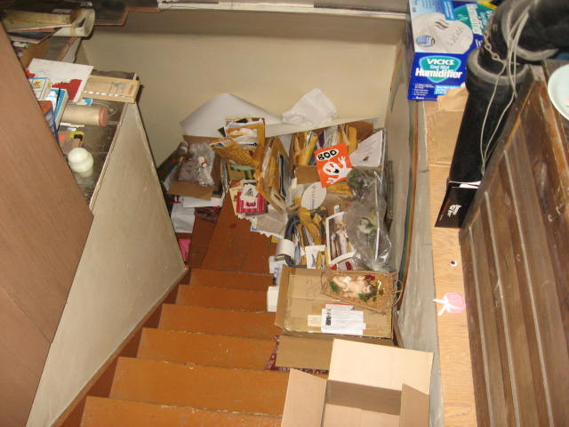
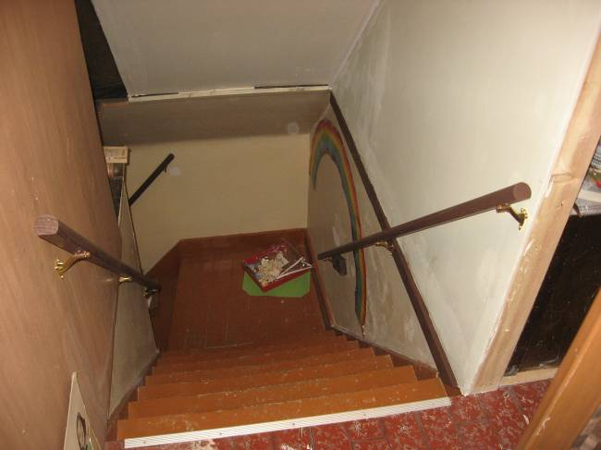

Image 2
Before: Cluttered stairs
Image 3
After: Stairs clear of boxes and clutter

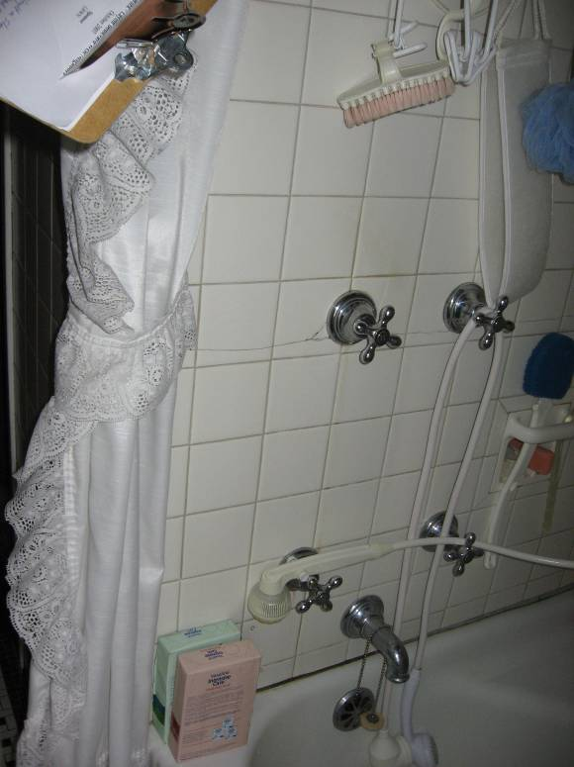
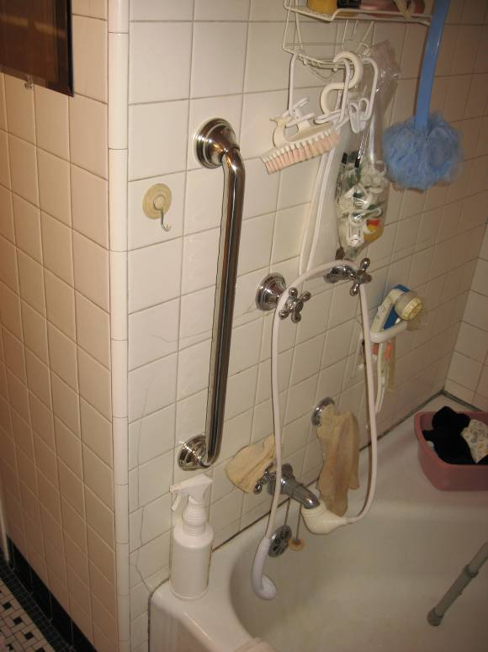

Image 4
Before: Shower with no grab bar to assist with transfers
Image 5
After: Shower with grab bar for easier and safer transfers

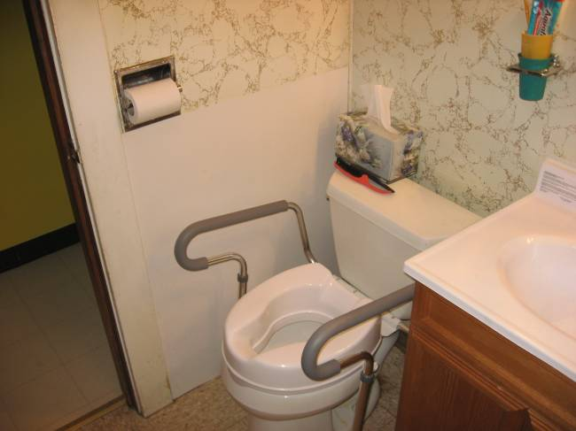

Image 6
Before: Toilet without raised seat and grab bars.
Image 7
After: Toilet with raised seat and grab bars to assist with transfers

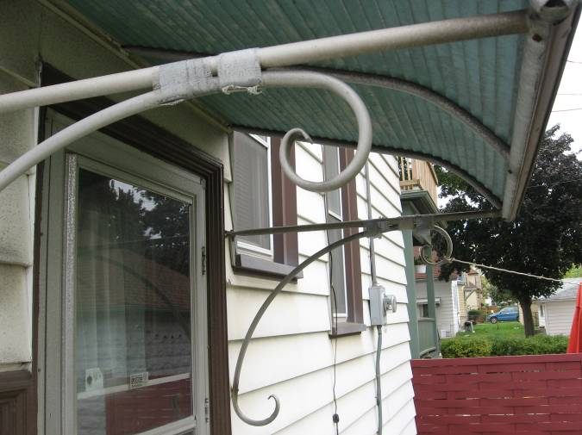

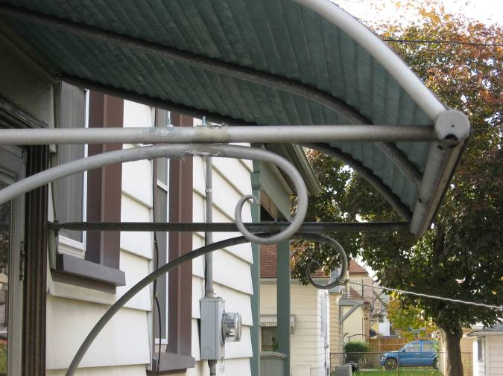
Image 8
Before: Awning taped together with duct tape
Image 9
After: Awning repaired with bolts

Appendix F

Equivalent Text Descriptions
Image 1: SHARP Process Flow Chart

Brief Description: Flow chart of SHARP process

Essential Description: This flow chart depicts the step-by-step process of the Senior Home Assessment and Repair Program. Nine rectangles connected by one line follow a downward diagonal path to the bottom of the page. The primary steps are: the UWM occupational therapy assessment, the Rebuilding Together remodeler assessment, and the homeowner approval to start repairs/adaptations. These steps are broken down and explained in each rectangle.

Image 2: Before Photo of Cluttered Stairs

Brief Description: Photograph of cluttered stairs

Essential Description: This photograph depicts a staircase full of clutter. The picture was taken from a downward angle from the top of the staircase to the bottom. The right side of the staircase is lined with boxes and other objects.

Detailed Description: The stairs in this photograph are light brown and the adjacent walls are white on the bottom and a darker brown on the top. There are no railings on the walls on either side. This photograph of a cluttered staircase was taken to show how unsafe it could be to walk up and down the stairs.

Image 3: After Photo of Stairs without Clutter and with Railing

Brief Description: Photograph of clutter-free stairs

Essential Description: This photograph depicts the same staircase as the previous photo taken at a downward angle from the top of the stairs to the bottom.

Detailed Description: This photograph was taken after the clutter was removed by the SHARP team. Clutter-free stairs are safer and easier to walk up and down. Also, railings were added on both sides of the railing by the SHARP team to increase safety while walking up and down the stairs.

Image 4: Before Photo of Shower without Grab Bar

Brief Description: Photograph of a shower without grab bars

Essential Description: This photograph depicts the head of the shower without a grab bar.

Detailed Description: In this photograph the head of the shower includes: the faucet, four on/off knobs, a handheld showerhead attachment, scrub brushes and a loofah. There is a white shower curtain on the left side of the photo. A clipboard is also visible in the top left corner of the picture. The photo shows that there is no grab bar on the wall to assist with transferring in and out of the tub.

Image 5: After Photo of Shower with Grab Bar

Brief Description: Photograph of a shower with grab bars

Essential Description: This photograph depicts the head of the shower with a grab bar installed vertically on the left side of the faucet.

Detailed Description: This is a photograph of the same shower as the previous photo; however, there is now a grab bar on the left side which will assist the homeowner in transferring in and out of the shower. Also, the white shower curtain is not visible in the picture.

Image 6: Before Photo of a Toilet without Raised Seat and Grab Bars

Brief Description: Photograph of toilet without raised seat and grab bars

Essential Description: This photograph depicts a toilet that does not have a raised seat or grab bars on each side.

Detailed Description: This photograph was taken before a raised seat and grab bars were added to the toilet. In the photo, the toilet seat is up, a kleenex box sits on the back of the toilet, the corner of the sink is visible on the right side, there is a cup attached to the wall above the sink containing toothpaste and a toothbrush, and a toilet paper roll on the wall on the right side of the toilet.

Image 7: After Photo of a Toilet with Raised Seat and Grab Bars

Brief Description: Photograph of toilet with raised seat and grab bars

Essential Description: This photograph depicts a toilet that has a raised seat and grab bars on each side.

Detailed Description: This photograph portrays the same bathroom as in the previous photo. The picture was taken after a raised toilet seat with grab bars was installed for safety. The wall below the toilet paper roll on the left side was repaired by SHARP.

Image 8: Before Photo of Awning with Duct Tape

Brief Description: Photograph of awning with duct tape

Essential Description: This photograph depicts an awning that is held together by pieces of duct tape.

Detailed Description: In this photo, the side of a house with an awning is shown; the awning is held together by pieces of duct tape. The house is white with brown trim and the awning is green with metal poles. Three windows can be seen on the side of the house. A brown fence is also visible in the background.

Image 9: After Photo of Awning Repaired with Bolts

Brief Description: Photograph of awning repaired with bolts.

Essential Description: This photograph depicts the same awning as the previous photo after it was repaired by SHARP; the duct tape was replaced with bolts.

Detailed Description: This photo shows the same angle of the awning as the previous photo. The awning was repaired by SHARP to improve durability and stability of the awning and also to increase safety.

