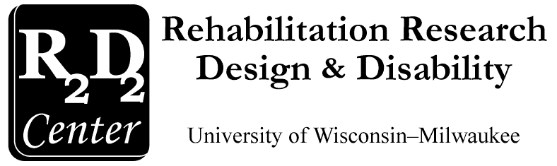

Rehabilitation Research Design & Disability (R₂D₂) Center
PO Box 413
Milwaukee, WI 53201-0413

(414) 229-6803 phone
(414) 229-5628 TTY

Universal Access Projects

Community Design Solutions (CDS)

Annual Report
May 2009 - May 2010

Community Design Solutions (CDS) aims to improve the quality of life in Wisconsin by designing or changing environments toward increased accessibility and refining decision making processes effecting the environment. CDS is involved in numerous projects including working with UWM’s Rehabilitation Research Design and Disability (R₂D₂) Center on the Milwaukee Idea Home, the ACCESS-ed Project, Design and Disability Instruction, and the Senior Home Assessment and Repair Project.

CDS Website: www.uwm.edu/MilwaukeeIdea/CDS/
R₂D₂ Center Website: http://www.r2d2.uwm.edu/
Table of Contents
Universal Access Projects 1
Community Design Solutions (CDS) 1
I. Executive Summary 4
II. The Universal Access Team 6
III. 2008-2009 Project Achievements 7
• ACCESS-ed Project 7
▪ Design and Disability Instruction: 8
▪ Milwaukee Idea Home: 8
▪ Housing Plus: 9
• UWM Campus Implementation of Physical Facility Design 10
• Websites: 11
IV. 2009-2010 Planned Activities 12
1. ACCESS-ed/ UD ITEACH 12
2. Milwaukee Idea Home 12
3. Instruction 12
4. Housing Plus 13
5. UWM Campus Implementation of Physical Facility Design 13
6. Website Design 13
7. Proposals and Projects 13
8. Theses 14
9. Collaboration and Community Outreach 14
Appendix A 15
R₂D₂ Center Bibliography - 2008 15
Thesis Projects 2008 16
Appendix B 17
P3 Audit Example 17
Appendix C 18
Housing Plus Occupational Therapy Checklist 18
Appendix D 19
Housing Plus Process Flow Chart 19
Appendix E 20
Housing Plus Commonly Used Products Binder 20
Appendix F 33
Housing Plus Follow Up Survey

Executive Summary


The Universal Design Team, based in UWM’s R₂D₂ Center and a component of CDS, successfully continued work on all projects. Following is a list of this years highlights:

- Senior Home Assessment and Repair Program (SHARP) transitioned to the Housing Plus program. The Housing Plus program includes more occupational assessors than SHARP and reaches ten thriving neighborhoods throughout Milwaukee County including the Layton Boulevard West Neighbors (LBWN). This past year Housing Plus completed assessments with ten homes and plans to complete twenty-five home assessments by the end of July. The Housing Plus team updated protocols, procedures, assessment tools and now uses Google Calendar as a key communication hub.
- The ACCESS-ed Project continues to promote UD and create new resources, such as posterettes, in its extension year.
- R₂D₂ updated our Accessible Design and ACCESS-ed websites and continued on the development of a ACCESS Mainstreet website, with funding from Pathways.
- At the 2010 International Association of Higher Education and Disability (AHEAD) Conference, Denver, Colorado, two staff members from the R₂D₂ Center organized and lead a 2 day Pre-conference/Symposium, with invited speakers, as well as having presented a concurrent session and a poster on the UD ITeach Project.
- R₂D₂ staff and students attended and presented at the July 2010 Rehabilitation Engineering and Assistive Technology Society of North America (RESNA) conference in Las Vegas, NV.
- Four of our graduate students completed M.S. research theses and one student completed a Ph.D. related to Universal Design.
- Three of our graduate students proposed new M.S. research theses related to Universal Design.
- Three R₂D₂ staff and students continued a second year of teaching a highly inter-disciplinary Design and Disability course in the Fall of 2009.
- Our teams successfully wrote and received three grants for over one million dollars: UD ITEACH ($1,000,000) and ($80,000).

This year’s activities continued to follow the theme of incorporating universal design (UD) into physical, instructional, and informational environments to promote cutting edge campuses and communities that shift from accommodating and adapting for individuals to infusing universal design and accessibility from the beginning. Overall, the past year’s activities have generated increased interest in the topics of universal design and accessibility in the community. We look forward to the upcoming year of activity.

The Universal Access Team

Roger O. Smith, Ph.D.
Professor, Occupational Therapy
Director, Rehabilitation Research Design & Disability (R₂D₂) Center

Staff Contributing to CDS Related Projects:
- Aura Hirschman, MS, CRC
- Melissa Lemke, MS, Biomedical Engineering
- Kathy Longnecker Rust, MS, OT
- Tereza Snyder, BFA, Programming
- Randy Will, BS, Engineering
- Keith Edyburn, BS, Engineering

Graduate and undergraduate students:
    - Lindsey Fletcher, BS
    - Carrie Jennerjohn, BS
    - Kati Liegl
    - Kristen Lueck, BS
    - Autumn Milanowski

2008-2009 Project Achievements


ACCESS-ed Project

ACCESS-ed (Accessible Campus Climate Environment Support Systems for Education) was a project designed to develop and test processes that deliver low-cost universal design of instructional, information media, and physical environments to higher education campuses nation-wide. The project was supported in part by the U.S. Department of Education’s Office of Post-secondary Education and maintains a collaborative partnership with CDS. Over this past year, several ACCESS-ed workshops, presentations, and conferences have been conducted on topics such as measurement of accessibility on post-secondary campuses, how to infuse Universal Design knowledge and use, in post-secondary education (UDE), and replication of the Departmental Accessibility Resource Coordinators (DARC) system. In addition to providing information and workshops, ACCESS-ed developed numerous resource tools, strategies, and products for universal design in post-secondary education. Posterettes have been created for educational purposes on many different topics including: Universal Design in Education, Accessible Logos, Bulletin Board Installation Guidelines, and Remodeling Guidelines (Refer to Appendix C for example). Audits continue to be created as a part of this project are available on the ACCESS-ed website (Refer to Appendix B for a sample audit). There has been continued research on the impact of universal design strategies in post-secondary education. This grant concluded during the reporting period.
The ACCESS-ed team started work on a second tier three-year grant proposal from the Department of Education, Office of Post-seconday Education (OPE) called “Universal Design Infusion of Technology and Evaluation for Accessible Campuses of Higher Education (UD ITEACH)”. This project began in the spring of 2009.

- Design and Disability Instruction:

The Design and Disability (OCCTHPY 625) course brings together current and future professionals from different backgrounds and disciplines to teach the concepts and application of universal design. This course was first taught as an elective in the fall of 2007 to students in the occupational therapy and architectural graduate programs among others. Now, several years later, this course is a requirement for the Assistive Technology and Accessible Design Certificate, in the College of Health Sciences, and with its greater advertisement, more students have enrolled to take it as an elective. The course offers a new way of thinking creatively to apply the techniques of universal design in various settings and professions. The Assistive Technology and Accessible Design Certificate, mentioned above is a fifteen credit program focusing on the knowledge and application of assistive technology and universal design principles to prepare students for work in different areas of clinical practice. Support and collaboration for interdisciplinary students as well as involvement in student research has been provided throughout the past year of both SARUP and CHS graduate students. Thesis and dissertation instruction and advising continues to be provided for students within the R₂D₂ Center (Refer to Appendix A for Bibliography).

- Milwaukee Idea Home:

The MIH is a project of CDS that was designed and built for accessibility which is currently being used by IndependenceFirst as a transitional housing facility. The project is also being utilized for instructional purposes such as class demonstrations and field trips. It provides students an incredible opportunity to experience and learn about accessibiliy and universal design first hand.

MIH Website: www.uwm.edu/MilwaukeeIdea/CDS/

- Housing Plus: 

Housing Plus is a community-based project in which occupational therapy students from UWM collaborate with Rebuilding Together Greater Milwaukee (RTGM) and ten thriving neighborhoods in Milwaukee County. The team provides home assessments, recommends environmental modifications and adaptive equipment, and implements repairs to improve safety, function, and independence to promote aging in place for senior homeowners living in Milwaukee County. Housing Plus is a multi-component program involving several sequencial steps. First, the RTGM coordinator reviews homeowner applications to check eligibility. If eligible, the RTGM coordinator interviews the homeowner and compiles a document with information about the homeowner. Next, the RTGM coordinator schedules an occupational therapy assessment. The occupational therapy assessment is conducted with two student assessors, one community-based occupational therapist and one contractor. The contractor and an occupational therapy student assessor interview and evaluate the home with a family member of the homeowner while the community-based occupational therapist and occupational assessor conduct a home assessment with the homeowner focusing on safety and functionality of the adult in their home. After the assessments are completed, the team meets at the RTGM office to discuss recommendations and changes that need to be made to he home. After a consensus is made regarding recommendations the occupational therapy assessors compile resources for the homeowner and locate devices needed to meet recommendations. The student assessors complete documentation which then goes to RTGM for a final review with the homeowner. With the approval of the homeowner, the purchase and installation of the adaptive equipment and implementation of the repairs and modifications of the home environment are completed.
The transition from the Senior Home Assessment and Repair Program (SHARP) to the Housing Plus program involved improvements to the program. In December of 2009, four new occupational therapy students were hired and trained to facilitate home assessments for Housing Plus. One student was appointed as coordinator of the Housing Plus team to work with the RTGM coordinator. The two coordinators communicate through Google Calendar and email for all scheduling and document exchange. Additional adjustments to the program include the update of assessment tools and assessment protocol, increasing efficiency in documentation, as well as creating three new tools for Housing Plus.
Since December, Housing Plus completed ten home assessments and by the end of July the program plans to complete 15 more homes. In addition to completing all 25 home assessments, Housing Plus assessors have decided to volunteer their time to complete a follow up survey with all home owners. The assessors hope to track the changes made to the home and the outcomes of their suggestions. The information gained from this survey will work to further improve the Housing Plus program.


UWM Campus Implementation of Physical Facility Design

With the input of numerous colleagues, Assessment of Universal Design Informational Tools ( AUDITs) have been created to assess the design, usability, and accessibility of the campus. These AUDITs have been used by professionals and students to evaluate different areas throughout the university and have been submitted to the campus implementation teams.

- Websites:

R₂D₂ Center staff members continue to collaborate to provide technical assistance and support for the creation, edits, and launching of various, accessible R₂D₂ websites such as ACCESS-ed and ACCESS Main Street. The R₂D₂ website continues to grow with newly updated resources including links and descriptions of ongoing projects and videos.

2009-2010 Planned Activities

Community Design Solutions allows us to continue working in a variety of ways in the area of universal design and accessibility. As always, a set of new and continuing activities, including both community-based, and campus-based projects are anticipated for the current and coming year. Although we know the long list of activities that are desired can not all be accomplished in a short time, it is our hopes to continue with our current projects and expand our support for future projects. Planned activities include:

- ACCESS-ed/ UD ITEACH
      - ACCESS-ed continues to make accessible products and resources available as an example for other websites, developers, etc.
      - Continued work on a three year grant and research titled “UD ITEACH, a Demonstration Project to Ensure that Students with Disabilities Receive a Quality Higher Education”

Milwaukee Idea Home
      - Continuation of home tours as part of instructional courses.

- Instruction
      - Fall Design and Disability course to graduate students across schools and colleges (CEAS, CHS, and SARUP).
      - Continuing to offer the Assistive Technology and Accessible Design Certificate to both undergraduate and graduate students for continued education
      - Ongoing interdisciplinary support and collaboration to graduate students across colleges related to universal design.

- Housing Plus
      - Completion of 25 total home assessments
      - Recruitment and training of new occupational therapy students as home assessors.
      - Housing Plus assessor volunteer completes follow up visit and survey with all homeowners and gathers data to improve the program.
      - Incorporating the knowledge and skill of the architectural students from CDS.

- UWM Campus Implementation of Physical Facility Design
      - Coordination with Physical Plant about accessible design.
      - Support to the UWM library for remodeling.
      - Involvement in 20 year UWM Campus Master Plan
      - AUDITs of the campus environment for accessibility
      - Establishing campus committee for accessibility with remodeling and new campus projects

- Website Design
      - Updating and editing of the websites and improving the accessibility as an example to the public within the R₂D₂ Center website.

Proposals and Projects
      - Proposed project in 2009 to complete “Pathways ACCESS Main Street”
      - Proposed project in 2009 Mainstreet AUDIT: Personal Information Resource on Accessibility”.
      - Two graduate students and one post-professional student submitted proposals to the College of Health Sciences to fund their research involving different aspects of universal design. All three proposals were accepted and each student received $500 for their studies

Theses
      - Manuscript preparation of thesis work to be published by graduate students in the R₂D₂ Center
      - Three graduate students in the R₂D₂ Center beginning thesis work

Collaboration and Community Outreach
- Aura Hirschman, R₂D₂ staff member continues to be actively involved in the UWM Chancellor’s ADA Advisory Committee (ADAAC)

Appendix A

R₂D₂ Center Bibliography - 2008

- Anson, D. & Smith, R. O. (2008). Equivalent text descriptions - A proposed standard. Proceedings of the RESNA 31st International Conference on Technology and Disability: Research, Design, Practice and Policy.
- Anson, D., Rust, K. L., & Smith, R. O. (2008). Equivalent Text Descriptions - Why and Where. Retrieved May 15, 2008, from http://access-ed.r2d2.uwm.edu/.
- Anson, D., Smith, R. O., Hirschman, A., & Rust, K. L. (2008). Procurement tips for acquiring accessible goods and services that work for everyone including people with disabilities (Version1.2). Retrieved May 10, 2008, from http://access-ed.r2d2.uwm.edu/.
- Anson, D., Hirschman, A., & Smith, R. O. (2008). Writing equivalent text descriptions (Version1.2). Retrieved May 6, 2008, from http://access-ed.r2d2.uwm.edu/.
- Hirschman, A., & Smith, R. O. (2008). DARC Position Description Posterette. Retrieved May 15, 2008, from http://access-ed.r2d2.uwm.edu/.
- Hirschman, A., & Smith, R. O. (2008). Top 10 tips for universal design in the classroom. Retrieved April 30, 2008, from http://access-ed.r2d2.uwm.edu/.
- Maggard, K. R. & Smith, R. O. (2008). Measuring the quality of text equivalents to multimedia information. Presented at the International Conference on Aging, Disability and Independence, St. Petersburg, FL.
- Mendonca, R. J., Jansen, C., Smith, R. O., John-Gomez, C., & Katz-Petted, L. (2008). Inter-Disciplinary Based Evaluation and Intervention for a Senior Home Repair Project. Presentation at the International Conference on Aging, Disability and Independence, St. Petersburg, FL.
- Mendonca, R., Smith, R. O., Lemke, M., & Winters, J. (2008). Expert validation of the MED-AUDIT (Medical Equipment Device-Accessibility & Universal Design Information Tool). Proceedings of the RESNA 31st International Conference on Technology and Disability: Research, Design, Practice and Policy.
- Mendonca, R. J., & Smith, R.O. (2008). Quantifying the accessibility of medical devices: Development and validation of the MED-AUDIT. Presentation at the International Conference on Aging, Disability and Independence, St. Petersburg, FL.
- O'Connor, T., Christiaansen, R., Anson, D., Rust, K., & Smith, R. (2008). Test and test items AUDIT (Version 1.6b). Retrieved April 30, 2008, from http://access-ed.r2d2.uwm.edu/.
- Rust, K. L., Anson, D., & Smith, R. O. (2008). Test and test item AUDIT (Version 1.6b) instructions. Retrieved April 23, 2008, from http://access-ed.r2d2.uwm.edu/.
- Smith, R. O., Hirschman, A., & Kastner, M. (2008). A student measure of campus accessibility: The ACES taxonomy. Presented at the 31st annual international AHEAD Conference, Reno, NV.
- Smith, R. O., & Hirschman, A. (2008). Departmental accessibility resource coordinators (DARCS): A network approach to changing campus climate. Presented at the 31st annual international AHEAD Conference, Reno, NV.
- Smith, R. O., Pickens, N. D., Rust, K. L., Siegler, S., & Mendonca, R. (2008). Evidence based measurement of accessibility for occupational therapy practice: Tools and techniques. Institute presented at the American Occupational Therapy Association, Long Beach, California.

Thesis Projects 2008
Kim, J. (2008). The effectiveness of using a protocol for preparing and delivering a universally designed presentation and its impact on students learning in higher education. Unpublished master's thesis, University of Wisconsin-Milwaukee.
Maggard, K. R. (2008). The efficacy of an equivalent text description protocol for increasing the accessibility of information. Unpublished master's thesis, University of Wisconsin-Milwaukee.
Paprocki, C. (2008). The effect of multifocal lenses on attentional capture. Unpublished master's thesis, University of Wisconsin-Milwaukee.

Appendix B

P3 Audit Example

Appendix C

Housing Plus Occupational Therapy Checklist
*Created by Sandy Ceranski and Kristen Lueck.

Appendix D

Housing Plus Process Flow Chart
RTGM coordinator reviews homeowner application to check eligibility
RTGM coordinator interviews homeowner and documents interview to share with OT assessors

Coordinators work to schedule visit with homeowner
Assessment conducted with homeowner and HP Team
Team meeting takes place at RTGM to discuss recommendations and changes

Occupational assessors find resources and complete documentation

RTGM completes final review of document and takes to homeowner for approval

Purchase and installation of equipment, modifications and repairs completed

Volunteer Housing Plus assessor completes follow up interview and survey

Image 1:
Housing Plus Process Flow Chart

Appendix E

Housing Plus Commonly Used Products Binder

*Assembled by Kristen Lueck and under constant revision as products and resources develop


Housing Plus

Commonly Used Products

Table of Contents
Front Porch 3
Railing
Chair Lifts
Ramps
Living Room 7
Chair Lifts
Support Poles
Off Set Hinges
Kitchen 11
Utensils
Cooking Aids
Cleaning Aids
Bathroom 15
Shower Chairs
Elevated Toilet Seats
Toilet Frames
Bath Tub Grab Bars
Hand Held Showers
Commodes
Self Care Aids
Bedroom 24
Bed Rails
Dressing Aids
Mobility 27
Canes & Walkers
Automobile 28
Transfer Aides
Resources 31
Examples:

Railing

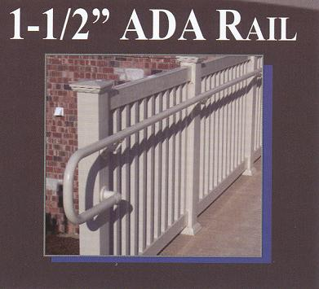
Chair Lifts

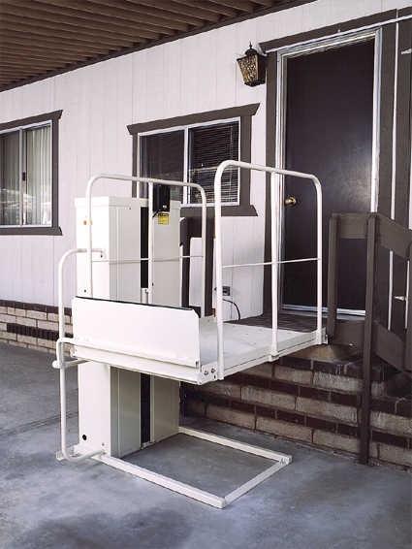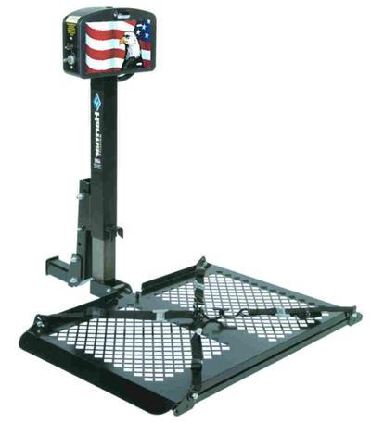

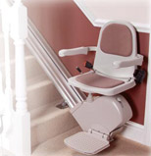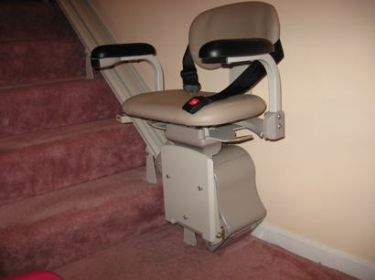
Ramps

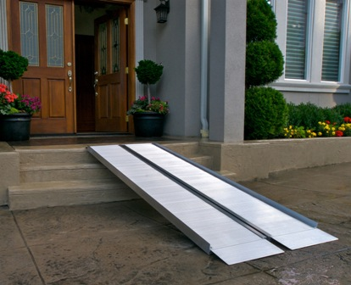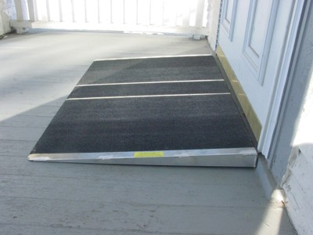

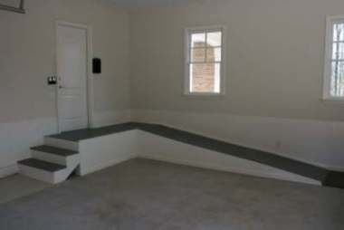
Kitchen Utensils

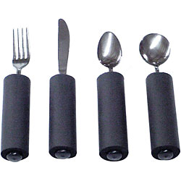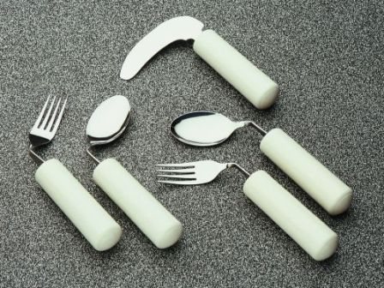

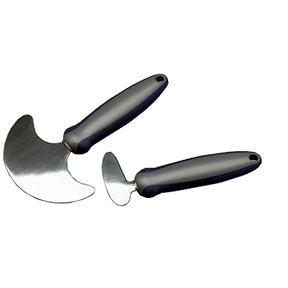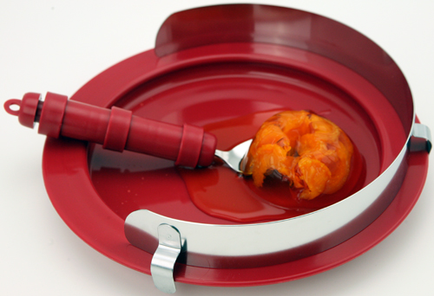
Cooking Aids

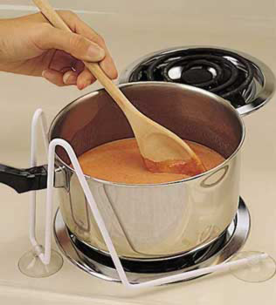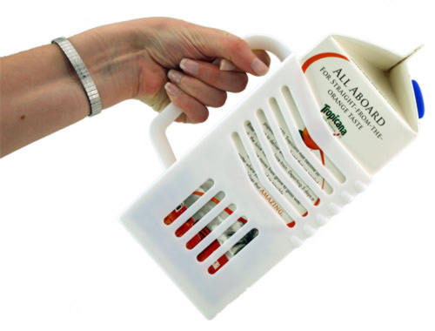

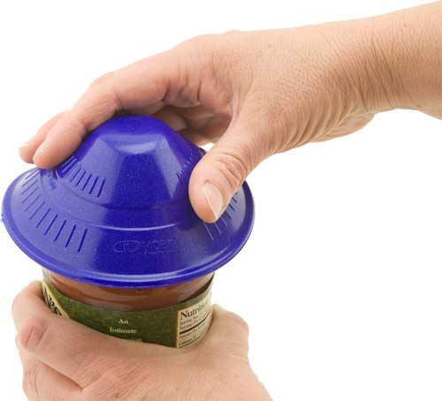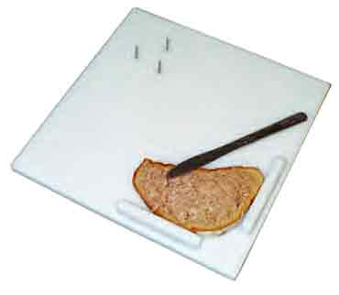

Cleaning Aids
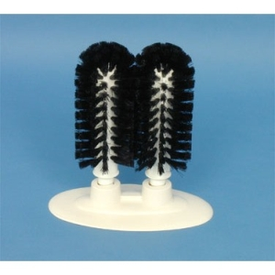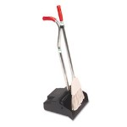

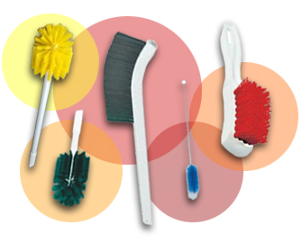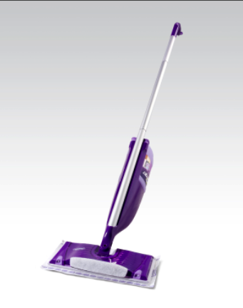
Elevated Toilet Seats
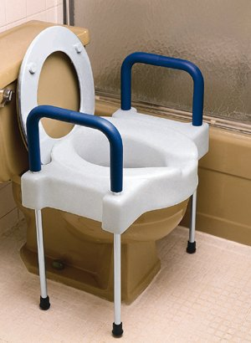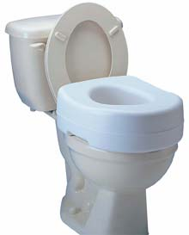
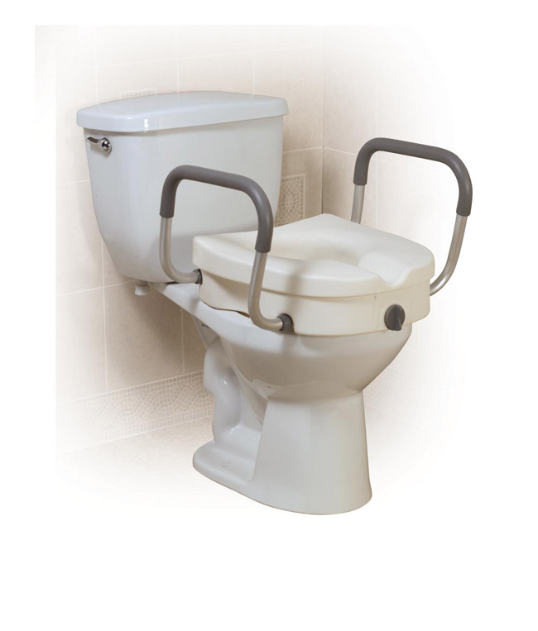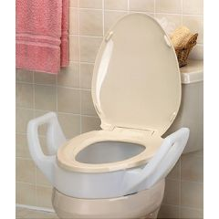
Toilet Frames
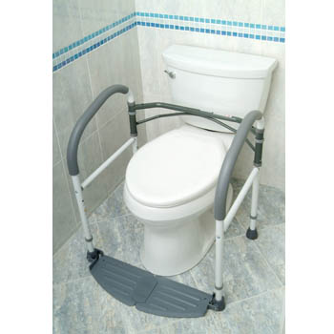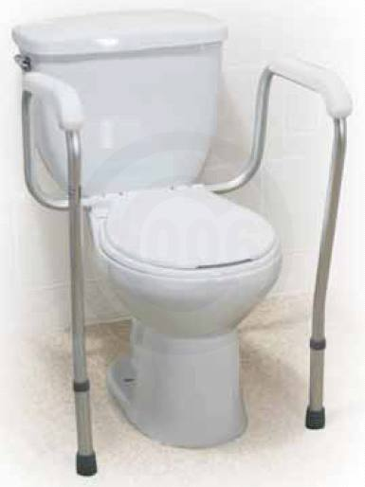

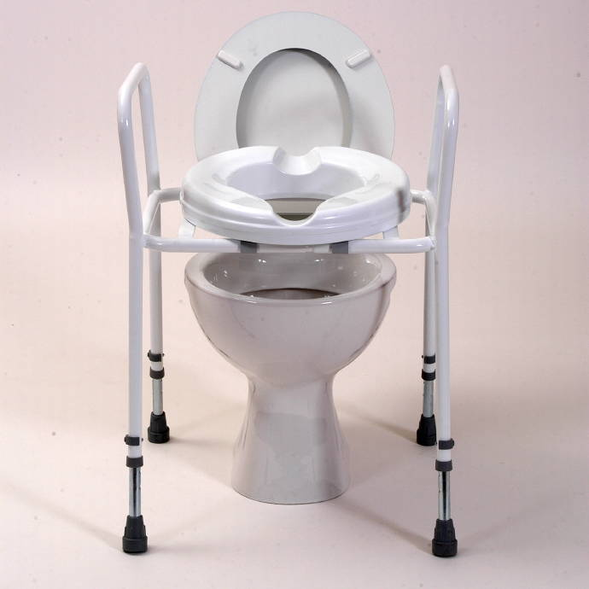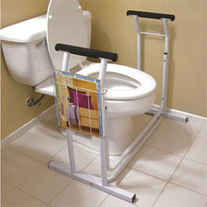
Bath Tub Grab Bars

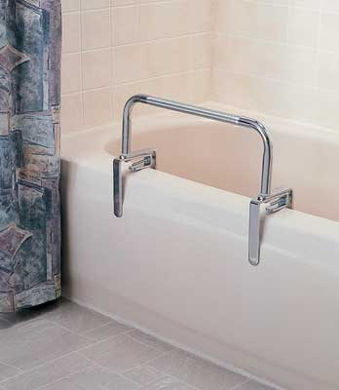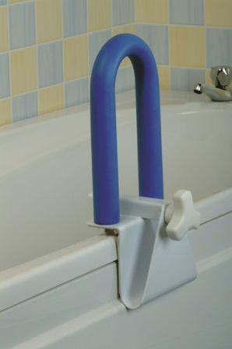

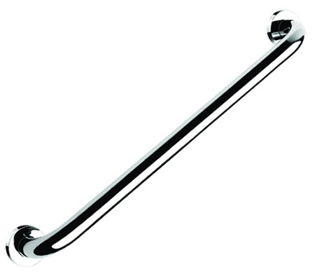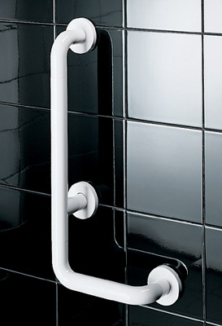
Resources

Web
http://www.carepathways.com/estore.cfm
Company founded by Clare Absher RN, BSN. Family owned and operated since 1999. Website has ‘estore’ catering to the geriatric population specifically. The comprehensive website offers recourses and information for caregivers and clients alike.
http://www.disabilityproducts.com
Arizona based company recognized by the Better Business Burro as an accredited business. This online store offers aides for all people with disabilities. This site offers numerous options for kitchen, bathroom, bedroom, driving, recreational and ADL tools.
http://www.caregiverproducts.com
Founded by therapist Amy Wright and her husband in 1999, this company focuses on finding simple solutions to every day obstacles for people with disabilities. Their ‘gadgets for independence’ section of the website gives aides for the kitchen, dressing, mobility, pain control and arthritis. This site also offers numerous information videos for caregivers.
http://www.enablemart.com
This internet store prides itself on offering ADA and barrier free products. This store offers high end American made products for furniture, shower seats, shower systems, toilets, sinks, faucets, bathrooms, grab bars, and kitchens. The site offers a financial resource guide with information regarding local agencies, grants, loans, state programs and information for veterans.
http://www.abledata.com
This is a website offing information on products for people with disabilities but does not sell them. As a National Institute on Disability and Rehabilitation Research (NIDRR) funded site, it offers cutting edge technology and products for people with disabilities, all of which have been tested.
http://www.lifesolutionsplus.com
This site is from a corporation from Pennsylvania catering to older adults and individuals with disabilities. This site sells all the products features and tests them for safety.
http://www.health-mobility.com
Health-Mobility is an online retailer located in Kansas. The company prides itself on keeping costs low to consumers while offering excellent customer service. This site is easy to navigate and has numerous picture of each device along with an explanation of its use.
http://www.milwaukee.gov/DISPLAY/ROUTER.ASP?DOCID=7705
This is The Milwaukee County Department on Aging website offering recourses and information for elders in Milwaukee and their caregivers. Milwaukee Area Stores

Wheelchair Recycling Program
http://www.wrp.org
3540 N. 126th Street  Unit F  Brookfield, WI 53005  (262) 439-8248 | 2711 W. Wells Street  (Warehouse – By appointment only)  Milwaukee, WI 53208
The Wheelchair Recycling Program stocks a large selection of canes, crutches, walkers, bath stools, bath chairs, commodes, grab bars, raised toilet seats and over-bed tables. Call with other specific needs to check stock for devices.

Wal-Mart & Target
Carries walkers, wheelchairs, canes, bathtub grab bars, hand held showers, toilet frames, commodes, elevated toilet seats, electronic lift chairs and more. Some stores carry items in-stock, other stores you have to place an order.

The Home Depot
Carries walkers, canes, bathtub grab bars, hand held showers, commodes and elevated toilet seats. Some stores carry items in-stock, other stores you have to place an order.

St. Vincent de Paul
2320 W. Lincoln Ave. Milwaukee, WI 53215
(414) 672-2040

Appendix F

Housing Plus Follow Up Survey
*Created by Kristen Lueck and currently under review and revision by R₂D₂ center staff.

Home Owner’s Name:

Date of follow up meeting:

Device or home modifications:

Date of installation, home modifications or device provided:

Questions for Home Owner | Yes | No
Have you received any follow up information regarding your home assessment and suggestions made for improvements to the home?
Provide paperwork and go over occupational therapy suggestions. Have homeowner sign off on 2 copies of Occupational Therapy Suggestions. Keep one copy for Housing Plus records and leave a copy for the home owner.
WAS THIS COMPLETED?
Have you used the new device or home modification?
Have you received training about how to use this device or modification?
If NO, occupational assessor please provides training now.
Will you continue to use the device in this fashion?

If NO-
Do you have another way of using it?
Please explain:

Are you satisfied with the device or modification?
If no, why?

Do you feel the device or modifications improve
your safety?
Do you feel that the device or modifications will help
you remain in your home longer?

Additional Home Owner Comments:

Questions for Occupational Assessor | Yes | No
Were devices provided or home modifications made to the home?
Are changes consistent with suggestions made through Occupational Therapy Suggestions form?
Are devices or modifications done to a lesser (or greater) degree than suggested or with an alternative device?
If yes, please explain.
Do you feel that the device or modification made (even if not consistent with your original suggestion) will improve the safety of the home owner?
Are you satisfied with how the device or modification was installed and completed?
Was additional education of the home owner needed to ensure proper use the device or home modification?
Does the home owner’s current abilities allow for the use of the device or modification as intended in original suggestion?
Are you satisfied with the follow up with the home owner?
If No, please explain and provide suggestions for improvement.

Additional Occupational Assessor Comments:

