Summary of Home Safety Assessment: X

Assistive Equipment Recommendations:
- Stairway to second floor
- Glow in the dark contrast tape on stairway to second floor
- 2 railings, 2 vertical grab bars
- 2 toilet seat safety frames
- Bath bench with a back
- 3 vertical grab bars in bathtub
- Handheld shower
- Stairway to basement
- 2 railings, vertical grab bars
- Sharkbite (Nonskid) paint on front stairs
- Outside railings replaced

OT Functional Home Safety Recommendations

Outside Home:
- Paint front steps with Sharkbite to increase traction.
- Replace outside railings.

Inside Home General:
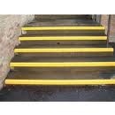
- Stairway to second floor:
- Add glow in the dark contrast tape on stairway to second floor to increase contrast, increase traction and reduce the risk of falls. (see photo)
- Add railings on both sides of the stairs. The window side railing should extend across the window, to decrease the risk of falls on the stairs.
- Add 2 vertical grab bars: one to the top of the stairs on the interior wall side which will finish off the shortened railing and one on the bottom inside turn. Vertical grab bars allow for support while making turns on the stairway, thus decreasing the risk of falling.
- Stairway to basement:
- Add railings on both sides of the stairs to decrease the risk of falls on the stairs. On the inside wall of the home, extend the railing at the top turn when the new railing is added.
- Add a vertical grab bar at the turn on the inside wall at the bottom. The vertical grab bar allows for support while making turns on the stairway, thus decreasing the risk of falling.

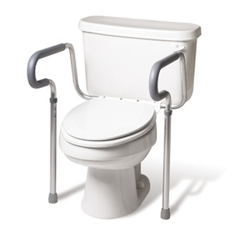
Bathroom:
- Upstairs bathroom:
- Install a toilet safety frame to make getting off the toilet easier and provide additional stability. (See photo)
Toilet Safety Frames from Walmart
$26.94
- Install a handheld shower. This will allow for showering while sitting, thus reducing stress and the risk of falling in the tub. (see photo)
Handheld Shower from Walmart
$11.99
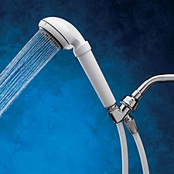
- Install vertical grab bars on each side of the window to reduce the risk of falls. One of there grab bars should have a holder for the handheld shower head to rest while it is not in use. The vertical grab bars will be used when getting into and out of the tub in addition to supporting the user while they bend and reach while showering.
- Install a vertical grab bar to the vanity side head of the shower to reduce the risk of falling while transferring into and out of the tub and retrieving the shower head and shower items.
- Install a bath bench with a back to allow for sitting while showering which will help conserve energy which reduces the risk of falling. (see photo below)
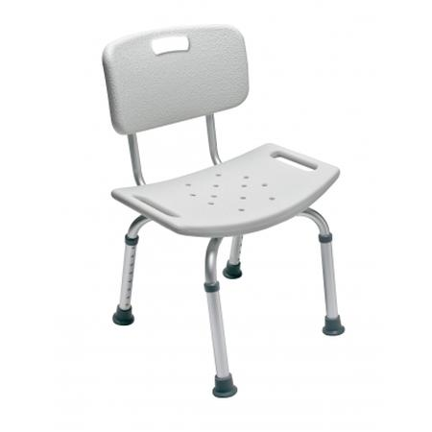
- Downstairs bathroom:
Bath bench with back from Walmart
$38.98
- Install a toilet safety frame to make getting off the toilet easier and provide additional stability. (See photo above)

Additional Resources:
- X could benefit from a vision assessment at the Badger Association of the Blind and Visually Impaired. The Badger Association appointments are covered by Medicare. The contact information is as follows:
- Badger Association of the Blind and Visually Impaired
912 N. Hawley Road
Milwaukee, WI 53213
414-258-9200
- Please see brochure: http://www.badgerassoc.org/pdf/Low_Vision_Flyer.pdf

What You Can Do to Prevent Falls
Many falls can be prevented. By making some changes, you can lower your chances of falling:

Begin a regular exercise program
Exercise is one of the most important ways to lower your chances of falling. It makes you stronger and helps you feel better. Exercises that improve balance and coordination (like Tai Chi) are the most helpful. Lack of exercise leads to weakness and increases your chances of falling. Ask your doctor or health care provider about the best type of exercise program for you.
Have your health care provider review your medicines
Have your doctor or pharmacist review all the medicines you take, even over–the–counter medicines. As you get older, the way medicines work in your body can change. Some medicines, or combinations of medicines, can make you sleepy or dizzy and can cause you to fall.
Have your vision checked
Have your eyes checked by an eye doctor at least once a year. You may be wearing the wrong glasses or have a condition like glaucoma or cataracts that limits your vision. Poor vision can increase your chances of falling.
Make your home safer
About half of all falls happen at home. To make your home safer:
- Remove things you can trip over (like papers, books, clothes, and shoes) from stairs and places where you walk.
- Remove small throw rugs or use double-sided tape to keep the rugs from slipping.
- Keep items you use often in cabinets you can reach easily without using a step stool.
- Have grab bars put in next to your toilet and in the tub or shower.
- Use non-slip mats in the bathtub and on shower floors.
- Improve the lighting in your home. As you get older, you need brighter lights to see well. Hang light-weight curtains or shades to reduce glare.
- Have handrails and lights put in on all staircases.
- Wear shoes both inside and outside the house. Avoid going barefoot or wearing slippers.
Source: Centers for Disease Control and Prevention 1600 Clifton Rd. Atlanta, GA 30333, USA
800-CDC-INFO (800-232-4636) TTY: (888) 232-6348, 24 Hours/Every Day - cdcinfo@cdc.gov

