Summary of Home Safety Assessment: X

Assistive Equipment Recommendations:
It is recommended that X use two grab bars in the bathtub, vertical grab bar with “S” handle by toilet, flip down or stationary tub bench, three way switch in the bedroom, and instruction and use of walker. A further review of the assistive equipment is addressed below.

Suggested Home Environment Changes:
- Use the wheeled walker when moving around house to prevent falls. Using the walker can also help to reduce back pain if used as the occupational therapy assessor demonstrated during home assessment. Using the walker correctly should also help to increase energy during the day if pain is decreased. Keep a pain diary to check if pain is decreasing as the walker is used correctly and more often.
- Add three way switches to the bedroom so that you can switch the lights on and off from the bedside without getting up from bed. This will also make it possible to switch on and off from bedside and wall switch. This will make it easier to switch the lights on and off in emergencies or at night.
- Removal of the wheels on the bed will make the bed three inches lower to the ground to prevent falls and to make it easier to sit on the bed.
- Lowering of the threshold from the bedroom to hallway because of its height. This will reduce the risk of falls and injuries on the foot.
- To make using the shower easier, a horizontal grab bar should be placed below the window on the window sill (the grab bar from the toilet area can be reused). Also a vertical grab bar should be placed in the head (front) of the tub closer to the tub. These bars will allow you to easily lift yourself from a seated position.
- To make using the shower easier, a tub bench should be added to the back of the tub and used during showers. This will reduce the risk of falling when showering.
- The tile with the hole in the kitchen should be filled with apoxi to allow a chair to easily move on the floor and to prevent falls or injuries.
- A smaller microwave should replace the current microwave if possible. The smaller microwave should fit into the baker’s rack. This will allow for easy use of the microwave. This will save energy and prevent injuries.
- The refrigerator moved towards table during the assessment should remain in its new position. This new location allows the wheeled to easily fit through the walk way.
- Walker should be used in the kitchen to allow easier movement and reduce pain level. Adding a basket to the walker is also suggested as this will allow you to carry items around the kitchen while still using the walker in a safe, pain reducing manner.
- Adding shelving on wall above table could increase storage and make it easier store and reach materials during simple meals.
- Make an extra key to keep in the dead bold on the back door. This key should be kept in the door to ensure exit in the event of a fire or other emergency.
- To prevent falls when using stairs railings should be added to both sides on: the stairway to the backdoor and basement, the front side walkway into the backyard, and in the front of the house.

OT Functional Home Safety Recommendations

Outside Home:
A second hand railing should be installed to the front stairs of the home. The additional railing will allow both sides of the stairs to be used and help to prevent a fall. The front side walkway into the backyard should also have the railing stored on the side of the house restored.

To allow a return to gardening new gardening options are suggested.
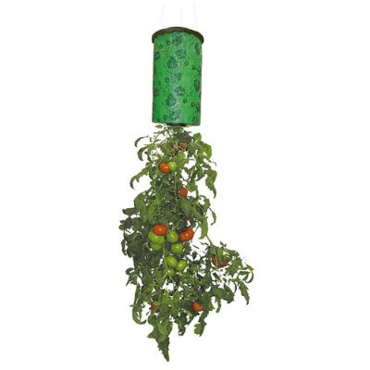
Topsy Turvy Tomato Planter will allow gardening on front porch which does not involve kneeing and bending over.

Sold at: Target, Walmart or online

Cost: $7-20
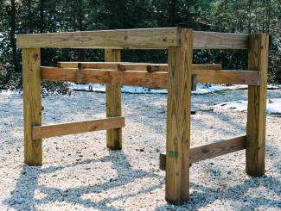
Gardenrack or home made raised garden could be used in the backyard at the location of the old garden. A raised garden bed would eliminate the need for bending and would allow gardening to be done in a seated position.

Sold at: http://www.garden-rack.com/ ($29.99), home depot, or online

Cost: $20-90

Inside Home General:
To prevent falls it is suggested that slippers with a back heal and rubber soles should be worn.

A cordless phone or cell phone should be carried with you if possible. This would allow you to contact others in the event of an emergency such as a fall.

As addressed during the home assessment, it is suggested that the wheeled walker be used when moving around the home, especially the kitchen. The proper use of the walked is needed to prevent back pain.
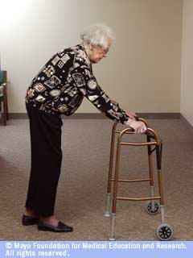
Remember do not bend over when using the walker.
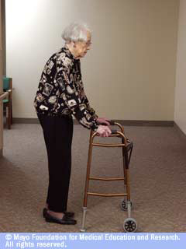
Stand tall when using the walker.
AND
Keep the walker close to your body.

As you properly use the walker around your home, keep a pain diary. The use of the pain diary will help to check if using the walker is reducing pain. Use the pain diary at least3 times a day for 2 weeks to monitor change. A suggested diary is located at: http://www.healthinaging.org/public_education/pain/my_pain_diary.pdf

To help reduce pain the following information is suggested for review:
http://www.arthritis.org/arthritis-pain-management-tips.php

Living Room/Dining Room:
None.

Kitchen:
To increase walking paths in the kitchen and space for storage a smaller square table could be used in the corner where the circular one currently sits. This would save space and allow for additional storage units between the table and refrigerator, while still maintaining the walking space needed for wheeled walker.

Bedroom:
The overhead light has one bulb burn out so it needs to be replaced.

Phone cord in the path of the bedroom to the kitchen should be moved to the side or replaced with a cordless phone to decease falls.

Available three way switches for suggestion # 2 above: http://www.homecontrols.com/Leviton-RF-Remote-Decora-Rocker-3-Way-Switch ($29.95)

Bathroom:
Brighter lighting in the bathroom to reduce the possibility of falls.

A smaller toilet could be installed to allow for easier movement in bathroom. A 14 inch or smaller toilet could be used. This new toilet would also allow the door to be replaced, as the door would not need a cut out to close.

For a safer toilet transfer you should remove the left grab bar and move the toilet paper from the side wall to the wall across from the toilet. These should be removed because they are in the way. A standing pole should be applied onto the wall across from the toilet so you can easily reach in front of you and grab to lift yourself up. The pole should contain a “S” handle grab bar for better grip and stability. Vertical grab bar could possibly be made by contractor by bending a metal pole and adding attachment parts.

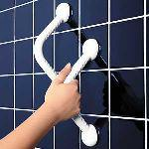 Safety Hand Grips/ Hand Rail http://www.bethmansales.com/group/group_bath_sbgbar.html
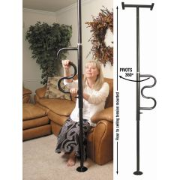 Security Pole and Curve Grab Bar

A tub bench should be placed in the foot (back) of the tub. The bench can be a stationary or flip down bench. The flip down will attached to the foot of the tub and the seat part will flip down. The seat will rest on the edges of the tube and will have legs that come down rest on the inside tub floor. The stationary bench will be attached to the foot of the tub and will sit on top of the edges of the tub. These benches will make it easier to get in and out of the tub. Contractor could possibly make stationary bench with certain materials.
http://www.allegromedical.com/daily-living-aids-c519/security-pole-and-curve-grab-bar-p555548.html
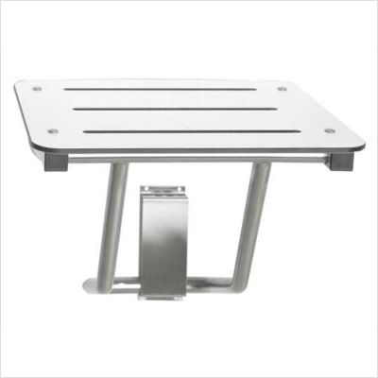 American Specialties Compact Folding Shower Seat http://www.wheelchairselect.com/American-Specialties-820-AME1147.html
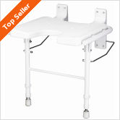 Nova Ortho-Med Inc Wall Mounted Shower Seat
http://www.wheelchairselect.com/Nova-Ortho-Med-Inc.-9404-NVM1152.html

Basement/Laundry Room:
Secure drain hose to basement tubs to reduce the risk of a fall. Install railings to the basement stairs. Provide more lighting in the basement to increase visibility.

