Housing Plus Image Gallery

Home A Modifications
Before | After | Description
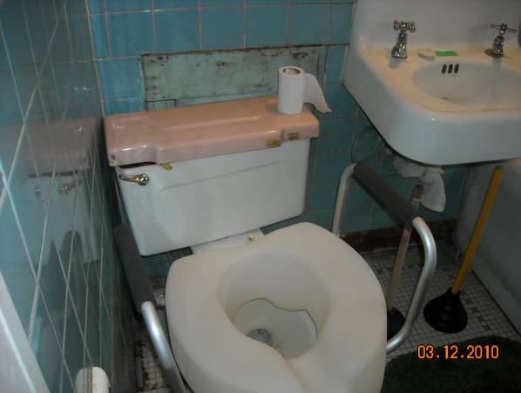 | 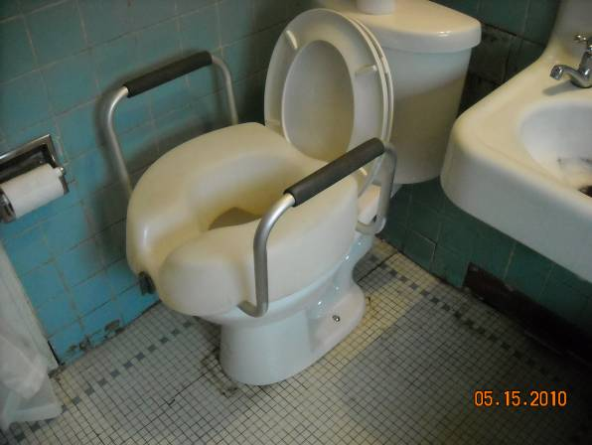 | The toilet in this home needed to be completely replaced. The homeowner also installed the raised toilet seat incorrectly causing a hazard for users since the seat was not secured on the toilet. The picture on the right features the new toilet with the raised seat installed correctly.
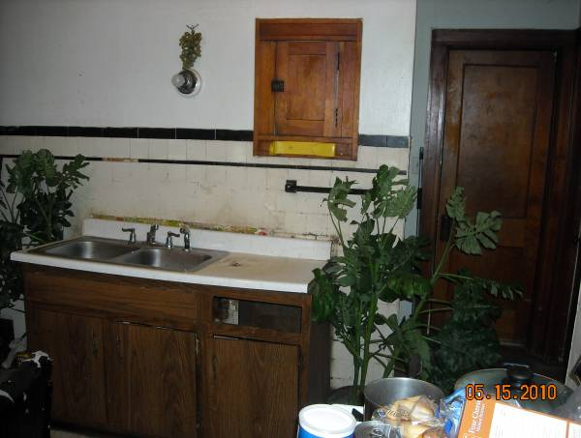 | 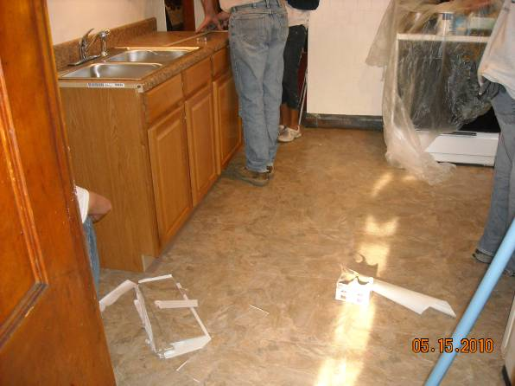 | The kitchen counter in this home needed to be completely renovated. The picture on the left reveals missing cabinet doors, cabinets without handles and a sink that does not work. The picture on the right features the newly installed kitchen counter and working sink.
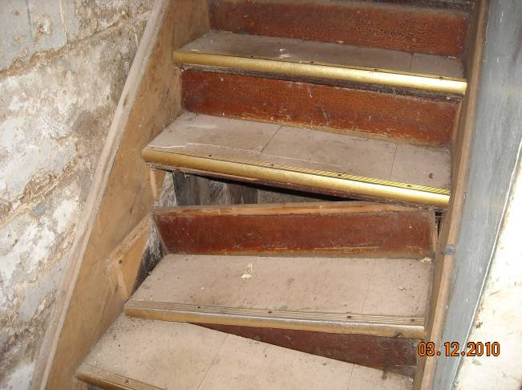 | 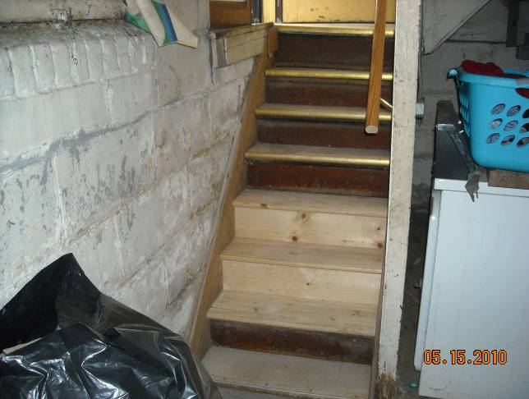 | The basement stairs in this home needed to be replaced. The picture on the left reveals several broken steps. The stairs pictured on the left also lack a railing. The picture on the right reveals the replaced stairs and addition of a railing.
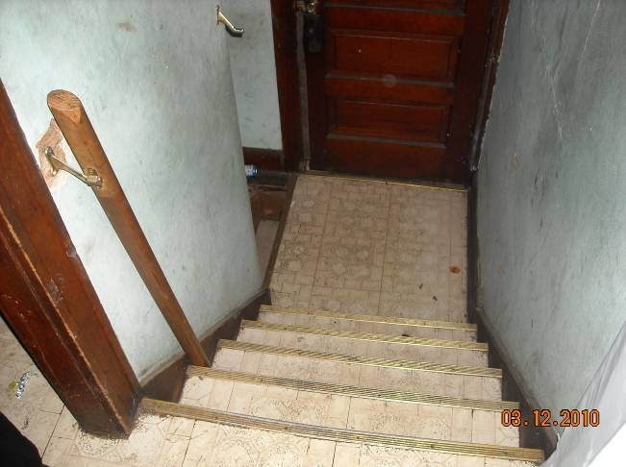 | 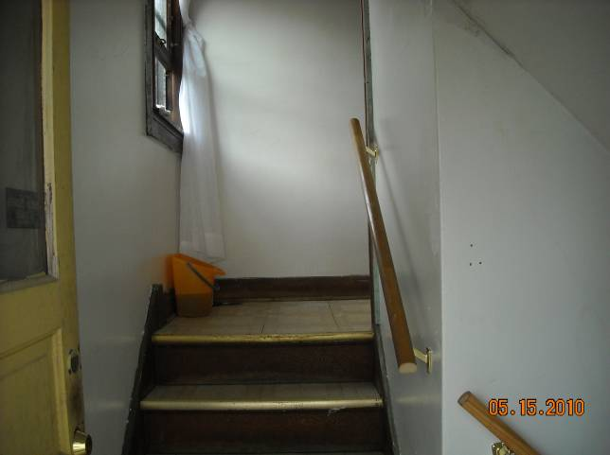 | This home also contained broken railings. The picture on the left reveals a broken railing and the picture on the right features the newly installed railing.

Home B Modifications
Before | After | Description
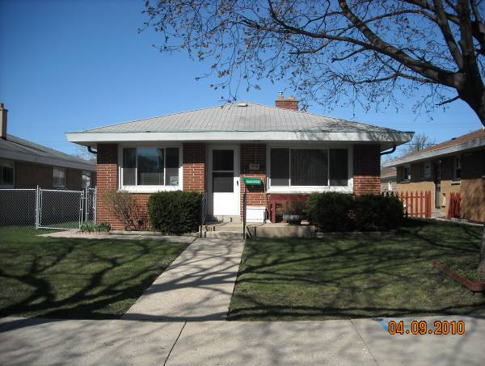 | 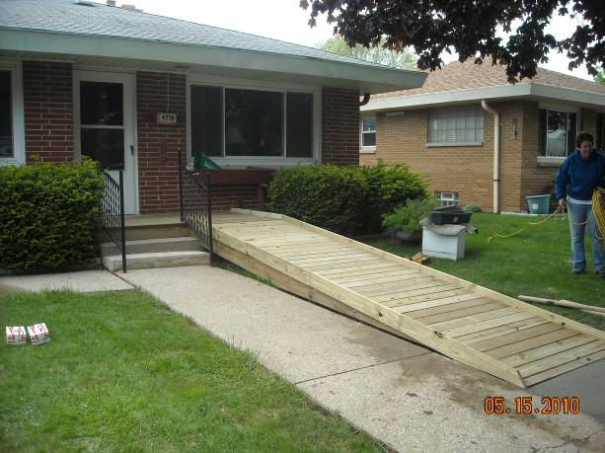 | This homeowner utilized a motorized wheelchair to maneuver the community. The house on the left features the home without a ramp. The home on the right features the newly installed ramp.

Home C Modifications
Before | After | Description
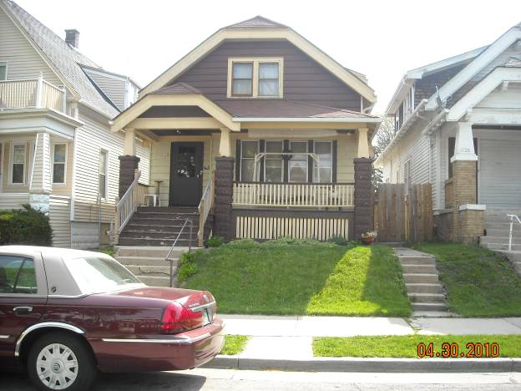 | 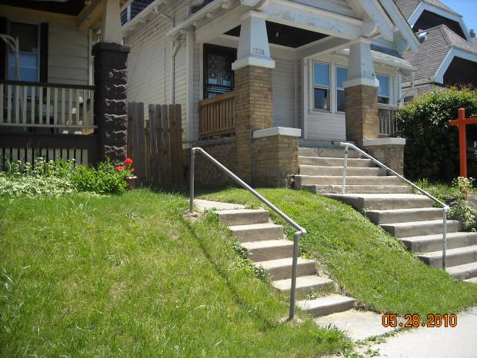 | This home needed a railing for the stairs to the backyard. The picture on the left reveals the stairway without a railing and the picture on the right reveals the railing installed.
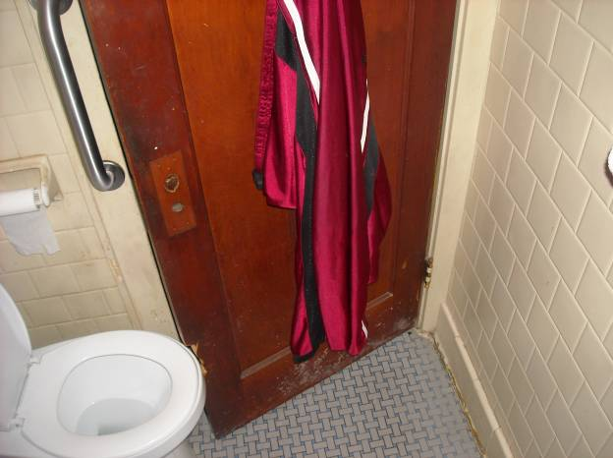 | 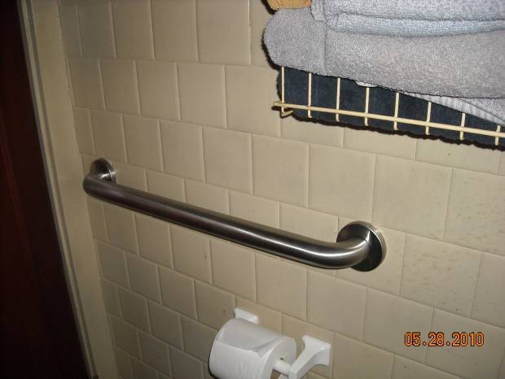 | This homeowner had difficulty sitting down on the toilet due to decreased lower body strength and the toilet paper roll and grabber that projected into their personal space. The picture on the right reveals the new placement of the toilet paper roll and grabber to allow the homeowner to comfortably use the restroom.

Home D Modifications
Before | After | Description
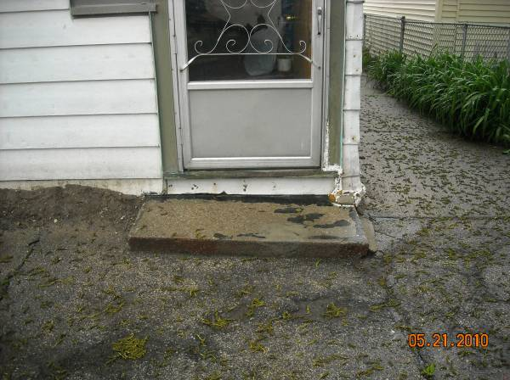 | 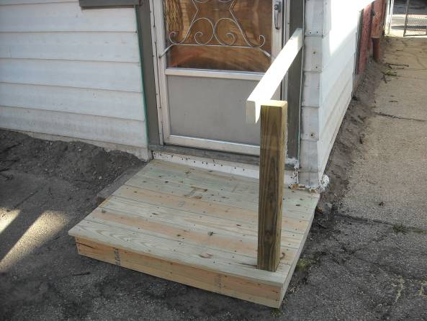 | This homeowner could not safely exit to their backyard due to the uneven cement step. The picture on the left reveals a steep step from the home to the cracked and uneven small cement step. The picture on the right features a newly constructed wooden platform and railing. The new platform provides adequate space for the homeowner and a safer step height for entering the home.

Home E Modifications
Before | After | Description
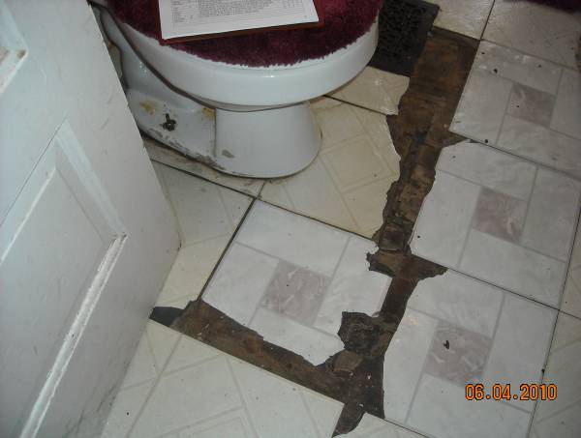 | 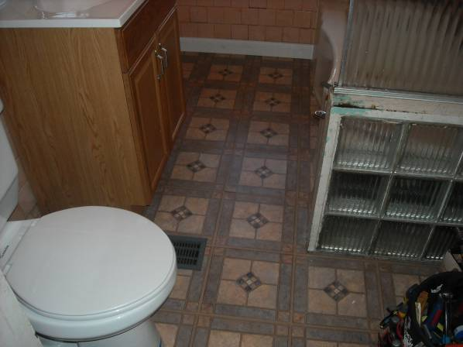 | This homeowner was unable to safely use their bathroom due to the cracked flooring and toilet seat which was too low. The picture on the right features the new bathroom flooring and newly installed higher toilet.

Home F Modifications
Before | After | Description
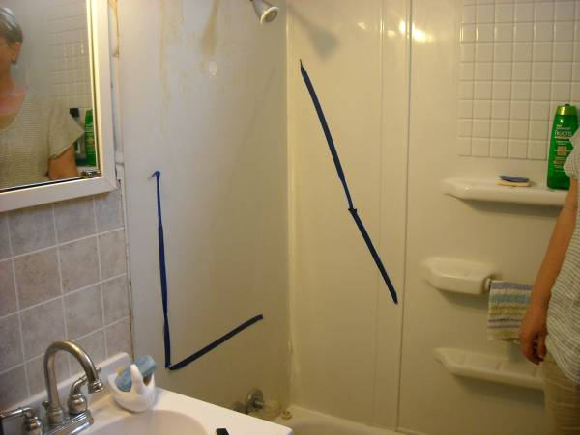 | 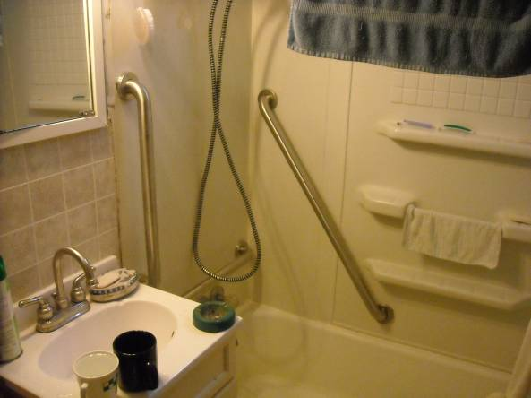 | This homeowner could not safely enter the shower without added stability. The picture on the right shows two grab bars that were installed to provide the homeowner with extra support.

Home G Modifications
Before | After | Description
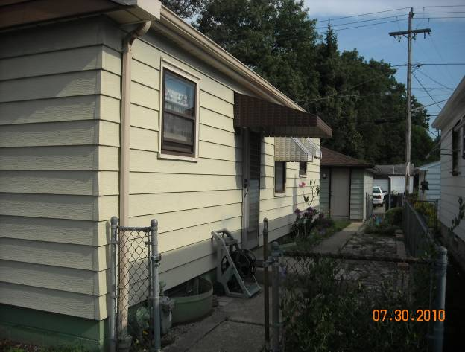 | 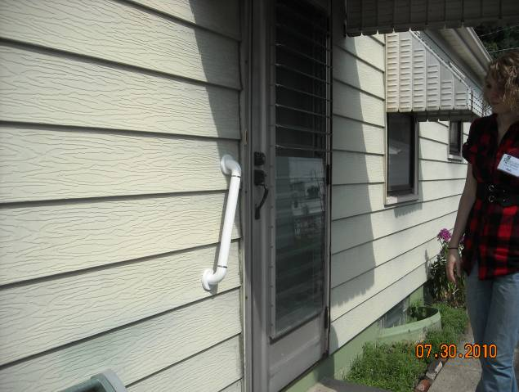 | The homeowner had difficulties entering and leaving their home because of the step leading to their door. The picture on the right shows a grab bar added to the exterior of the house. This grab bar provides support for the homeowner to safely enter and exit the house.
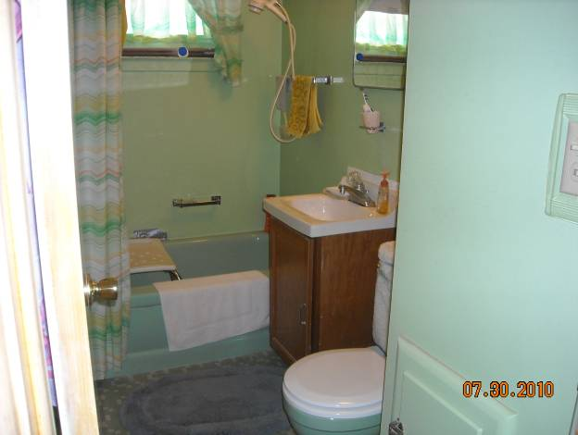 | 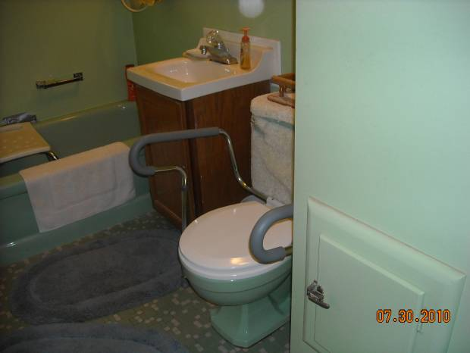 | The homeowner was unable to easily get on and off the toilet due to decreased lower body strength. The installation of a toilet safety frame allows the homeowner to use their upper body to help them get on and off the toilet without strain.

Home H Modifications
Before | After | Description
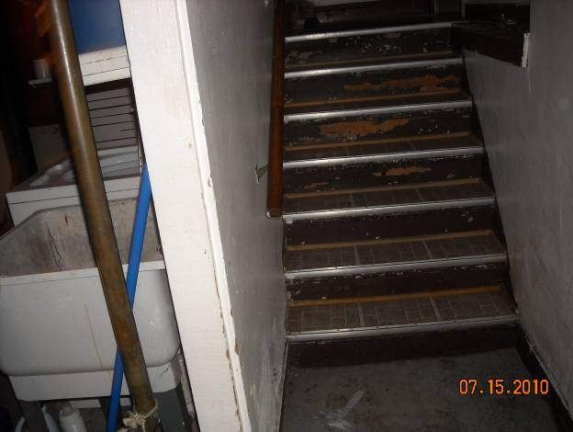 | 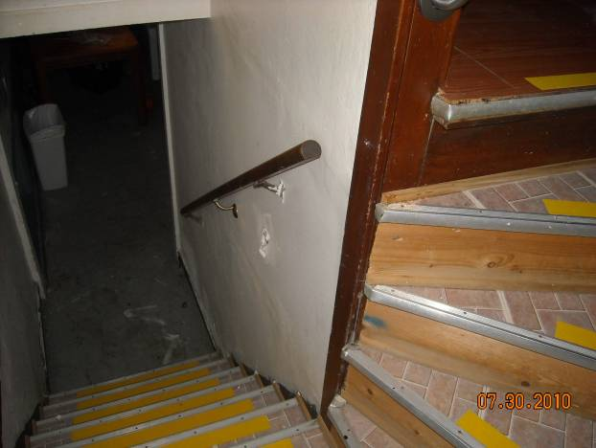 | The homeowner had difficulties seeing the stairs due to a decrease in vision. The picture on the right shows contrast tape added to the stairs to make them more visible. The textured tape also helps prevent against slipping.
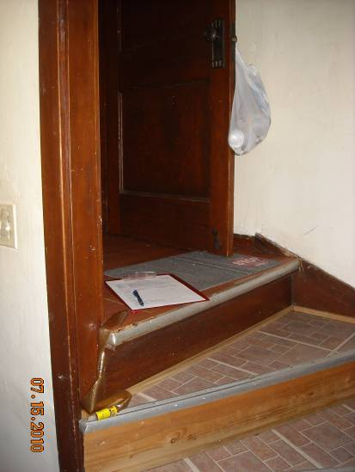 | 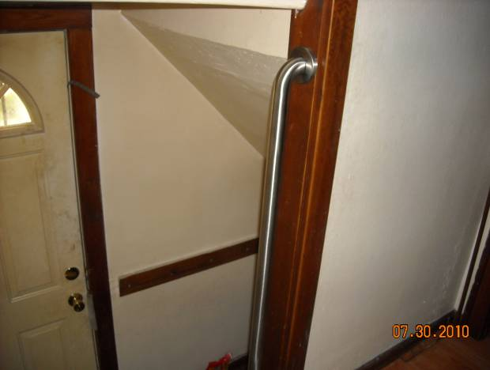 | The homeowner could not safely use the top step without additional support. The picture on the right shows the installation of a vertical grab bar. This grab bar assists with stability when declining stairs and supports homeowner when fatigued.
 | 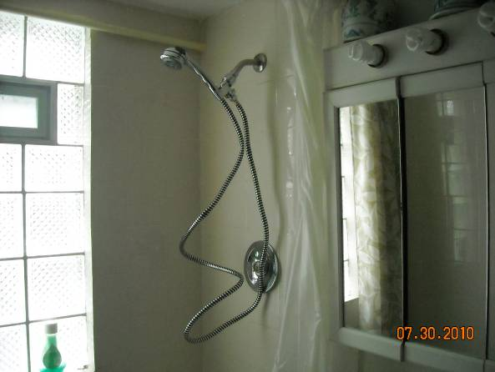 | This homeowner had difficulties standing in the shower for long periods of time. The picture on the right reveals the installation of a hand held shower. This addition allows seated showering and easy access to the shower head.

Home I Modifications
Before | After | Description
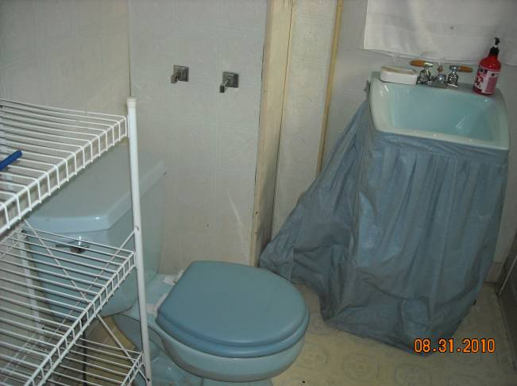 | 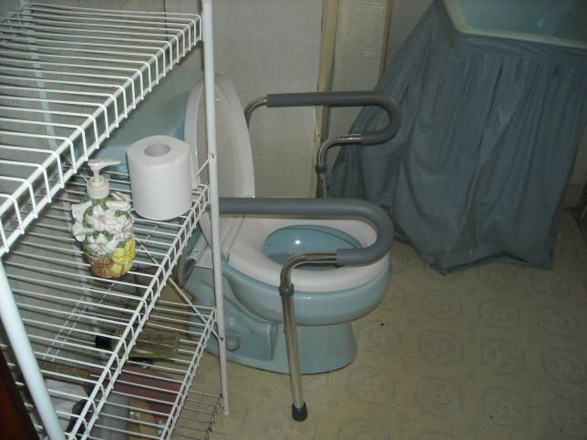 | This homeowner had difficulties using only their lower body to get on and off of the toilet. The installation of a toilet safety frame will provide the homeowner with bars allowing them to use their upper body strength. This will result in a safer transfer on and off of the toilet.
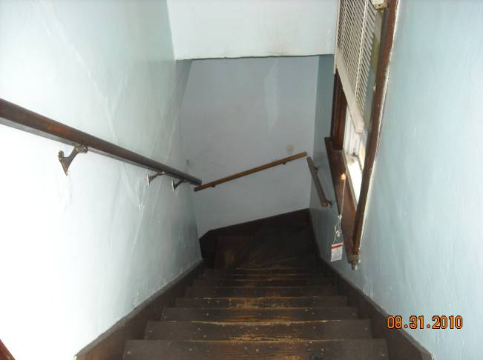 | 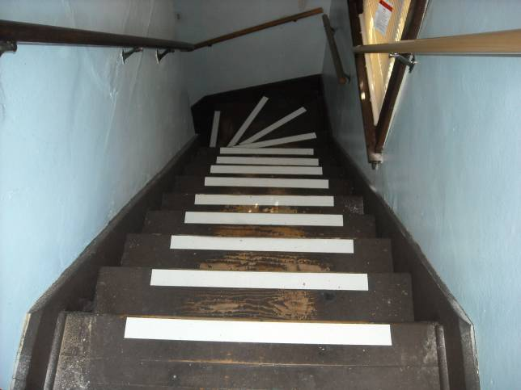 | This homeowner had a vision impairment which made it difficult to see stairs. Glow in the dark contrast tape was applied to the edge of the stairs which made them more visible and added light to the stairway. A railing on the right of the stairs was installed for extra stability.

Home J Modifications
Before | After | Description
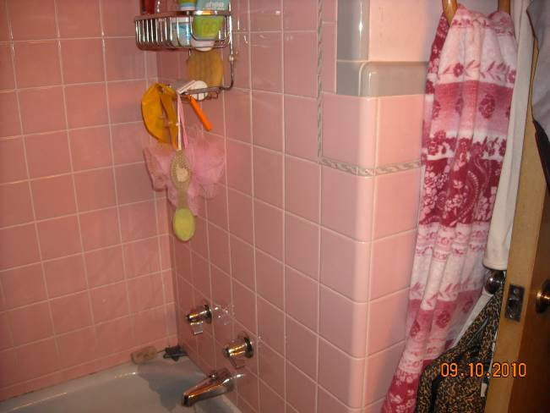 | 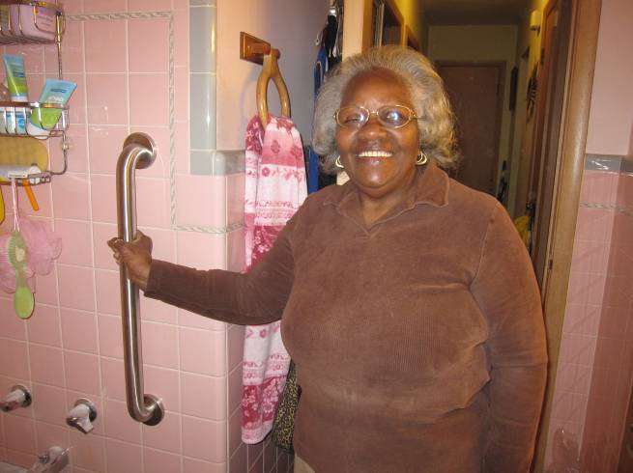 | This homeowner needed extra support when stepping in and out of the shower. The picture on the right shows the installed grab bar which will help the homeowner increase safety in their bathroom. The homeowner is happy with the results.

