Proper Use of a Walker
The proper use of the walked is needed to prevent back pain.
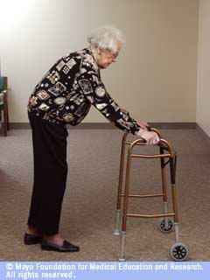
Remember do not bend over when using the walker.
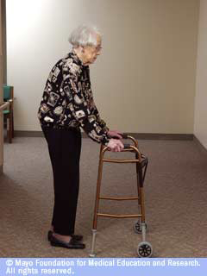
Stand tall when using the walker.
AND
Keep the walker close to your body.

As you properly use the walker around your home, keep a pain diary. The use of the pain diary will help to check if using the walker is reducing pain. Use the pain diary at least 3 times a day for 2 weeks to monitor change. A suggested diary is located at: http://www.healthinaging.org/public_education/pain/my_pain_diary.pdf

To help reduce pain the following information is suggested for review:
http://www.arthritis.org/arthritis-pain-management-tips.php

